
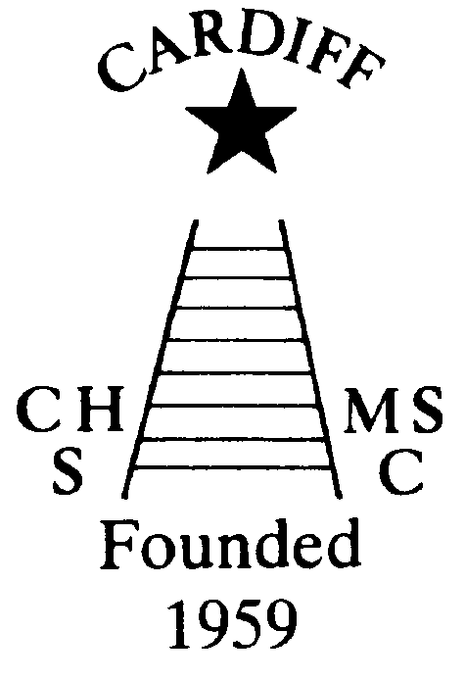
CHAMELEONS NEWS
The Monthly newsletter of the Cardiff Chameleons
Volume 27 Lockdown Issue: July 2020
Affiliated to:-Special Olympics GB Special Olympics Wales, MENCAP,
Welsh Sports Association for People with Learning Disabilities.
Registered Charity No. 1103879 / WEBSITE: www.cardiffchameleons.co.uk

Hello everyone!
This is just a special issue to give you a bit of information. As the Welsh Government and UK Government start to release lockdown measures we are still awaiting news about sports venues, so I think we are going to have to wait a little bit longer before our activities can restart. We also follow the advice of Special Olympics GB who will let us know about the restarting of any training and events. I have an item below about the Games next year.
As to Club social events, again we are going to have to hold fire on these too! We would probably have had our “afternoon tea” by now.

“50+” Club
As promised I have been doing the draws each month and the following are the lucky ones!

March winners are £15 - #42 Howard Ratcliff; £10 #48 Robin O’Donovan
April winners are £15 - #58 Carson Burnett; £10 #49 Peter Couzens
May winners are £15 - #15 Jill Clark; £10 #01 Arthur Exton
June winners are £15 - #12 Elaine Daw; £10 Owain Davies

SOGB National Summer Games Liverpool 2021
These Games have been postponed due to this coronavirus pandemic. They will now be held in 2022.
However, this is what SO Wales are planning to do; the deposit of £75.00 which has already been paid will be kept as this would have to be paid at a later date anyway. You will only get this back giving a reason that you do not want to take part in the rearranged Games and you would not be able to change your mind.
The last payment you made of £150.00 will be returned to you. However, this may take a while as the treasurer for SO Wales passed away and a replacement is underway but paperwork is just holding a few things up. All payments will now be due in 2021and we will advise you of the dates when they are due.

LOCKDOWN STORIES
I sent out an e-mail last month asking for your stories under the current times and Heather & Laura Knight sent in this…
…”Having sorted clothes, cupboards and drawers Laura and I have done a lot of walking. For the first few weeks we didn’t venture out of Cogan and Penarth Marina walking everyday either round Cogan Rec. or taking different routes around the Marina. Then we broke out and ventured up to Penarth town centre and found Brutons bread shop open so Saturday morning has been a walk up town bringing home cake.
Today, Thursday 25th June was huge change as Laura went back to work at Starbucks. It was like taking her on her first day at school and she got a cheer from the staff as she walked in. She came home tired but happy to be back.”
Thank you Heather, nice to see Laura is getting the economy going again!

There has been a notable lockdown birthday and that was celebrated by Gareth Clark who was the big 40 on the 22nd June. Congratulations Gareth!!

John Stafford celebrated his 67th birthday by having a little socially distanced drinks and cake with some of the neighbours. John has also had a “Zoom” meeting with his friends at “Causeway”.

I hope everyone who has had a lockdown birthday and those yet to have one; that it will be strange but memorable and that you enjoy it anyway.

I have received this message from Jeff Savory regarding the event below being held by Special Olympics GB.

Athlete Leadership Team Summer Fun Night
The Athlete Leadership Team will be hosting a Summer Fun night for athletes on Thursday 9th July starting at 5pm. It will be led by the Athlete Leadership Team as an opportunity to come together and have some fun. They will be doing a music quiz, some fitness activities and games etc.

Athletes will need to register beforehand by filling in this form https://bit.ly/2VkOqD2

This is needed from a security perspective so we can check who’s joining. Zoom details will then be e-mailed out before the night. We know this may be quite popular so the team will look to host other evenings if needed so nobody misses out.
This will be shared across our Special Olympics GB social media.

It was announced on the 6 o’clock BBC news (Monday 29th June) that the Special Olympics Winter Games are to be held in Kazan, Russia in 2022. They were originally going to be held in Sweden but they pulled out.
(By the way this was too late for those who have a paper copy of the newsletter as I had posted them in the afternoon!)

Finally…I will send out another newsletter in September and hopefully by then we will have some more information unless of course anything happens sooner.
In the meantime look after yourselves and stay safe.

How to contact us
Coaches | Pamela 029 2025 7314 / 07817 380355  pamela.bailey6@virginmedia.com | Robin  029 2021 8006 | Barrie 029 2075 3038  barriejenkins50@live.com
Treasurers  &  Newsletter | Elaine 029 2076 4770  elainemdaw@googlemail.com | Denise  029 2075 2909 | Steve 029 2025 7314  stephen.bailey497@ntlworld.com
Locations | Swim sessions:  Pentwyn LC: Monday 6.30pm – 7.15pm and Eastern LC Tuesday 8.30pm – 9.15pm
Locations | Bowls: Cardiff Bowls Club, Sophia Gardens: Friday 4pm – 6pm

