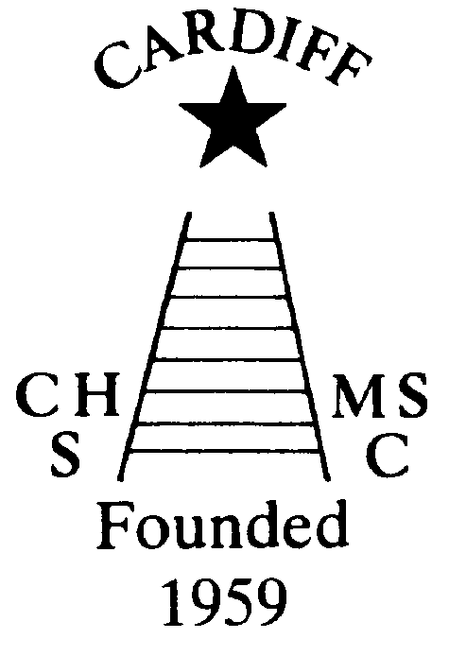
60 Years of
Achievement
Chameleons news 
The monthly newsletter of the Cardiff Chameleons
Volume 26: Issue 3: March 2019
Affiliated to:-Special Olympics GB, Special Olympics Wales, MENCAP,
Welsh Sports Association for People with Learning Disabilities.
Registered Charity No. 1103879
Website: www.cardiffchameleons.co.uk

1959

2019

60th Anniversary
Plans are now in hand for the meal which is taking place on Saturday 15th June at St. Peter’s Hall in Roath.
Enclosed or attached depending on how you receive the newsletter is your letter giving full details and if you wish to attend our special evening.
We have our DJ Nick booked already.
Here are some other events taking place during the year.
Barrie will be holding a Bowls competition on Sunday 31st March. At the Cardiff Bowls Club in Sophia Gardens.
A Club photograph will be taken on Sunday 7th April at 2.30pm at Howells School and will be taken in the area where we have our Afternoon tea and Barbecues.I also want to take an individual photograph of all athletes.
Please can you wear CLUB POLO SHIRTS (not the Special Olympics ones) the swimmers to wear their blue and bowlers to wear their white ones.

The Summer Afternoon tea will take place in July (date yet to arranged) and will be held at Howells school as usual and this year we think a 60’s theme would fit the bill. So mini-skirts and flowery shirts with butterfly collars to be worn and we’ll play 60’s music!
Our Club swimming gala is going to be a little bit special too, as we are going to invite swimmers to join us from two local clubs, Bridgend Sharks and Swansea Stingrays, and this will be on Tuesday August 6th with the Presentation evening on Tuesday 13th. However, as St. Philip Evans hall is booked that evening, we are going to be at the Cardiff Medical Centre Sports & Social Club, on the Heath hospital site, the same room as the swimmers & bowlers had their Christmas disco.
So please try not to book your holidays over these dates.

Pamela has booked a coffee morning for Thursday 17th October at St. Philip Evans Hall from 10am – 12noon.

Chameleons Anniversary 1959 – 2019
Celebrate by buying / selling our new Flashlight Pen.
Ideal for the winter nights!
Only £1.50 each [OR 3 for £4.00 – Bargain!]
Please contact Elaine for your supply of pens.
Many Thanks Elaine Daw – Tel:02920 764770 elainemdaw@googlemail.com

REMINDER
If you want to send any item to be printed in the newsletter, please submit it as a word document and as an attachment.

COFFEE MORNING
A big thank you for Myrtle Beech who held a coffee morning in her house, it was certainly very busy with people coming and going even for the short time that I was there. A grand total of £360.00 was raised for Club funds and not forgetting Alan Beech who sold £64.00 worth of pens too!
“100” Club
The February winners are:- £20 Ann Minchin, £10 Jenny Jenkins and £5 Chris Bourne. Congratulations!
The Special Olympics North West regional gala, (or as we know it as the Cheshire Penguins Gala). This is being held on Saturday 18th May so we will be travelling up on the Friday and return on the Sunday.
Please can you give Pamela your name by 31st March if you want to go as she will have to book in to the hotel etc.

There are some meetings coming up so here are the details…
A meeting of the Special Olympics Cardiff and Vale Region will take place on Monday 11th March in the Community room at Pentwyn Leisure Centre starting at 7.00pm.
The Special Olympics Wales AGM will take place on Sunday 17th March in the Sport Wales National Sports Centre, Sophia Gardens starting at 11.00am.
The Club committee are holding a meeting soon and if you wish to ask anything relating to the club, please can I have it in writing or e-mail by Tuesday 5th March.
Sandra Jones is running an on-line shop on Facebook, if anyone has any items to sell in aid of Chameleons, please contact Sandra.
A bucket collection held on Saturday 23rd February at ASDA raised £590.00. Thanks go to Alan Beech, Anne Marie, Simon and Julie, Wendy and Richard.

Bowls Group - The Schedule for 2019.
Friday 22nd March 2019 – Sunday 24th March
Torquay Bowls tournament (entries closed for this weekend.)
Sunday 31st March 2019 - Welsh Learning Disability Singles Tournament Cardiff. Please let us know if you are available.
Sunday 14th April – Development and Skill Assessment session for Tri-Nations 2-5pm
Monday 3rd June – 7th June - Learning Disability Tri-Nations International Falkirk. Team of 12 from Wales by selection.
Wednesday 12th June - Great Western Bowls tournament 16 names required.
September 7/8 - Regional Bowls Competition Pembroke. More details to follow.
Any queries please speak to any of the coaching team.

The Coaching Team.

Margaret Krawiecha, Delyth Jenkins

Sandra Jones, Barrie Jenkins, Dave Medlam.
How to contact us
Pamela  (swim coach) | 2025 7314  07817 380355 | pamela.bailey6@virginmedia.com  Committee member
Robin  (swim coach) | 2021 8006
Barrie  (Bowls coach) | 2075 3038 | barriejenkins50@live.com  Committee Vice Chair
Elaine | 2076 4770 | elainemdaw@googlemail.com  Club Treasurer
Denise | 2075 2909 | Committee member
Ian | 2023 3065 | Committee member
Jane |  | Committee member
Heather |  | Committee member
Sandi |  | Minute Secretary
Steve  (newsletter) | 2025 7314  07791 759360 | stephen.bailey497@ntlworld.com  Committee chair  33 Ty Cerrig, Cardiff. CF23 7DP
Club Sessions
Swimming | Monday | Pentwyn LC 8pm – 8.45pm
Swimming | Tuesday | Eastern LC 8.30pm – 9.15pm
Bowls | Friday | Cardiff Indoor Bowls Club,  Sophia Gardens 4pm – 6pm
Any items for the newsletter need to be in 5 days prior to the end of the month. Please put them in a word document and as an attachment to the e-mail. Thank you.
Articles submitted to the newsletter are included as written and are not subject to changes or necessarily the view of the editor.

