
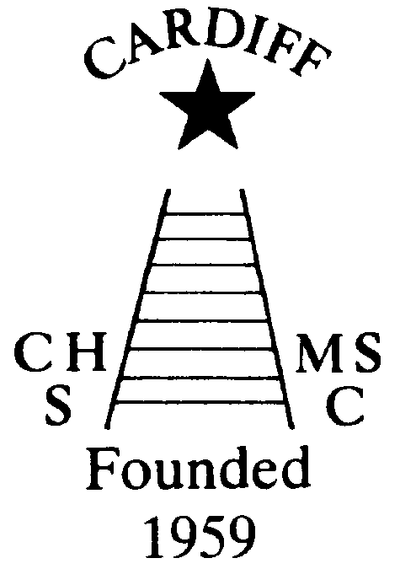
CHAMELEONS NEWS
The Monthly newsletter of the Cardiff Chameleons
Volume 27 Lockdown Issue 2: September 2020
Affiliated to:-Special Olympics GB Special Olympics Wales, MENCAP,
Welsh Sports Association for People with Learning Disabilities.
Registered Charity No. 1103879 / WEBSITE: www.cardiffchameleons.co.uk

Hello all!
I hope everyone is well. I was hoping that we would have had some better news to report but it looks like it is going to be sometime before we get back to swimming. Anyway in this issue here are a few items that you should know about.

“50+” Club
As promised I have been doing the draws each month and the following are the lucky ones!
July winners are £15 – Ian Marshall #52; £10 – Rhona Flynn #11.
August winners are £15 – Mike Clark #14; £10 – Barbara Kensett #60
We are going to continue with this next year, so I am giving you (very) early notice that payment of £12.00 will need to be with me by Friday 18th December. The prize money will stay the same.
Of course if you are not in this and you would like to join and help raise money for the Club please let me know. Steve. (Contact details below)

BIG THANKS to Pamela who did a “Facebook” fund raiser for her birthday back in July and raised £161.00, she also had some donations which made it up to £205.00 for Club funds.

BIG THANKS TOO! ... To Sandi & Carson who were willing to do our barbecue this year even though we are in a very different world. Those who attended enjoyed a dry but blowy afternoon. Everyone enjoyed the food and it was good for people to see each other after such a long period.
Many thanks again to Sandi & Carson for the catering and to Ian & Richard Marshall for setting up the tables and chairs.
We raised £154.10 on the raffle and we were given donations of £10.00 and £25.00
I have put some of the photographs I took of the afternoon on to my Flickr account. Just click on the following link … http://www.flickr.com/photos/best-pic … (it may take a minute but you’ll get there!) They will come up on the photostream or you can go into Clubs and click on Cardiff Chameleons.

RENEWAL OF CLUB ANNUAL SUBSCRIPTIONS – OCTOBER 2020 / SEPTEMBER 2021
At a recent committee meeting, it was decided to revise the amount of Annual Subs due in October. As the activities of the club have been curtailed [because of Covid-19] for approx. six months, the amount due on 1st October has been reduced to £10 [usually £20].
If all goes to plan, we hope to commence swimming/bowls in the near future and the Annual Subs of £10 will be collected either via the coaching staff or directly to Mrs. Elaine Daw, 11 St. Edeyrns Road, Cardiff. CF23 6TB. Cheques made payable to Cardiff Chameleons. Thank You.

I am still looking towards reducing the number of paper copies of the newsletter. If you have a paper copy but someone does have an e-mail address within your family or residence and they wouldn’t mind me using it for this and other Club related information, then please could you let me know, my details are on the contacts at the end of this newsletter.

AGM
Our Annual General Meeting which had to be cancelled back in April; will now be held on WEDNESDAY 21st OCTOBER at 7.30 pm at Howells school.
You are welcome to attend.

CONGRATULATIONS to Naomi Baelz from our bowls group who has been elected to sit on the National Advisory Council (NAC) of Special Olympics GB and she will be representing all athletes from Wales.

Barrie Jenkins has volunteered to be the Covid-19 officer for the Club. This is from Special Olympics Great Britain. Barrie will be dealing with the bowlers and Pamela will help by doing the swimmers. No doubt he will be putting information out as and when and I pass this on to you through general e-mails and notices.

SOGB National Summer Games Liverpool 2021
You will have heard that these Games have now been cancelled completely. Liverpool Council had to pull out due to insufficient availability due to other events being rescheduled.
I know that those of you who had put your names down to go will be disappointed, especially if you have been to Games before.
Due to the cancellation of the National Games in Liverpool, the deposits and first payments have now been refunded to the club.
Cheques have now been sent out to members. Elaine Daw – Treasurer.

Cardiff Chameleons Bowls Group Restart.
There have been no bowls training sessions since March 13th 2020 and I’m sure most of you will be itching to get back to training. Cardiff Indoor Club is starting to prepare for the return to Indoor Bowls.
Bowls Wales are in touch with the Welsh Assembly Minister for Sport and as soon as they get the go-ahead the guidelines will be published and issued to all Indoor Bowls facilities. A Covid-19 officer has been appointed and the required survey and risk assessments along with on-line training, will take place over the next couple of weeks. Hand Sanitizer stands have arrived at the club along with a Traffic light system, with temperature sensor and Track and Trace facilities. These will be in place by the time we return.
The Closest estimate for the return of Indoor Bowls at the moment is early October. If there is any change, I will update everyone as soon as possible.
As most of you are aware the Liverpool Games has now been cancelled. Refund cheques for those who were going to attend the games have now been issued and you should have received the refunds in full by the time the newsletter is sent out. We will be trying to fill the void by finding additional competition pathways, as well as the existing Regional, Welsh Championships and LDIBIS over the next few years.
LDIBIS press release for the Munro Cup went out this week and will take place in Cardiff June 15-17th.
Latest Update!!
The Covid-19 guidelines have been published by Bowls Wales and should be implemented in time for a return on Friday 2nd October. I will confirm the date nearer the time. Most of you will have received a membership renewal form from Cardiff Indoor Club. Only those members who normally bowl indoors in the mid-week leagues should complete and return these forms. All other memberships will be handled by the Chameleons block booking which is done annually.

Torquay Weekend Friday 26th March to Sunday 28th March 2021.
As many of you are aware, our payment for the Torquay Bowls Tournament 2020 has been credited to next year due to Covid-19.
If your names were included in this event, please can you confirm that you will be attending in 2021. Also, if your name was not included, but you would like to attend next year, please let me know?
There is a small increase in cost. However, depending on numbers, we hope this amount will be absorbed by the club. More information will be shared when it becomes available.
Elaine – 02920 764770 – elainemdaw@googlemail.com

IMPORTANT – Should there be any other events, please can you comply with requests for names to be given if you want to attend; for the barbecue I asked for names of those who wished to attend, however, there were people there who had not given in their name, not only was it for catering purposes but it was also for track & trace in case anyone subsequently develops symptoms of Covid-19.

How to contact us
Coaches | Pamela 029 2025 7314 / 07817 380355  pamela.bailey6@virginmedia.com | Robin  029 2021 8006 | Barrie 029 2075 3038  barriejenkins50@live.com
Treasurers | Elaine 029 2076 4770  elainemdaw@googlemail.com | Denise  029 2075 2909
Newsletter | Steve 029 2025 7314 stephen.bailey497@ntlworld.com  Items for the newsletter to be in 5 days before the end of the month and as a word attachment if sent by e-mail.
Locations | Swim sessions:  Pentwyn LC: Monday 6.30pm – 7.15pm and Eastern LC Tuesday 8.30pm – 9.15pm
Locations | Bowls: Cardiff Bowls Club, Sophia Gardens: Friday 4pm – 6pm

