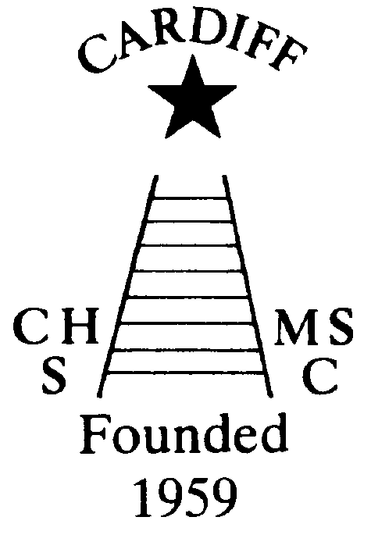
MEMBERSHIP RENEWAL
Chameleons’ news 
The monthly newsletter of the Cardiff Chameleons
Volume 25: Issue 10: October 2018
Affiliated to:-Special Olympics GB, Special Olympics Wales, MENCAP,
Welsh Sports Association for People with Learning Disabilities.
Registered Charity No. 1103879
Website: www.cardiffchameleons.co.uk

All members of the swimming and bowls need to renew their membership this month. The fee is £15.00 for the year. Please make payment to our Club treasurer- Mrs Elaine Daw, 11 St. Edeyrn’s Road, Cyncoed, Cardiff CF23 6TB.
Cheques made payable to Cardiff Chameleons.
A renewal form on the back page.

“100” Club
September winners were:-
£20.00 No.27 Sandi Burnett
£10.00 No.21 Andrew Knight
£5.00 No.19 Heather Knight
The lucky winners have been notified.
This was the last draw for the year.
If you wish to continue, or would like to join in, please send me your name and a cheque for £12 made payable to Cardiff Chameleons. You will be keeping the same numbers. If you do not cash your cheque and it has gone past the 6 months, no other cheque will be issued and the Club will keep the money. If we do not get enough people to run it to be profitable then I will return your payments and discontinue the 100 Club.
Due to Pamela and I moving house and the fact that not a lot of you have let me know if you wish to continue doing the 100 Club, I am deferring the start of this to January 2019. This has been agreed through the Club committee.

COFFEE MORNING
Pamela is holding this on Thursday 25th October at
St. Philip Evans church hall, from 10:30 until 12:30 and admission is £2.00, tickets are now available or you can pay at the door.
There will be a tombola, raffle and selling of homemade cakes.

Penarth Operatic &Drama Society
Denise has booked to see their production of
“The Darling Buds of May” on Friday 12th October. If you wish to go and see it please contact Denise on 2075 2909.

PEMBROKESHIRE PUFFINS GALA
This being held on Saturday 10th November down in Haverfordwest. If you wish to attend then please give your name to Pamela by Friday 12th October.

CHRISTMAS
Pamela is arranging a coach trip to the Christmas Market in Worcester. This will be on Saturday 1st December and is open to anyone and will cost £20.00 per person. Please give your name if you would like to go. It is an ideal way of doing some of your Christmas shopping.
Our Christmas Dinner and Dance will be held at St. Philip Evans Hall. The reason is that our usual venue was damaged in the bad snow fall earlier this year and may not be available in time. We will still use Spiro as he also does outside catering. The dinner will be on Friday 7th December starting at 7.30pm. The bar will be available and we will have the usual raffle and a disco. There is ample car parking. Further information will be given out at swim and bowls sessions, by e-mail and on the website.
A Christmas Disco for swimmers and bowlers is being arranged for Thursday 20th December at the Cardiff Medical Centre Sports & Social Club at the Heath Hospital. Starting about 7pm, there is no charge all we want you to do is to bring a plate of food for the buffet.
For further information please contact Pamela.
Sally Anne Bourne - The following is a tribute from Chris Maloney MBE of Special Olympics.
Very sad news, but I know Sally-Anne had a wonderful life and gave so much joy to her family and friends as she always shared her many outstanding sporting achievements.
Sally-Anne was a member of the Special Olympics swimming team which took part in the 1983 World Games in Baton Rouge, Louisiana, where she won medals in swimming and diving, the only diving medal won by a GB Special Olympic athlete.
Sally Anne was a proud member of the Cardiff Chameleons Swimming Club, one of the first groups to be part of Special Olympics GB.who always have a big team at our National games.
I will miss Sally-Anne and her big welcoming smile.
Chris Maloney. MBE
The GB winning swim team at the European games, Ireland 1985.
Sally Anne standing next to Sargent Shriver, husband of Special Olympics founder, Eunice
Kennedy Shriver
.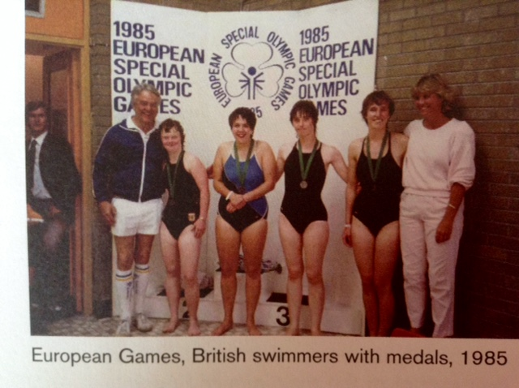

The Club are also grateful to Christopher Bourne (Sally-Anne’s brother) and Neeta Joshi (Sally-Anne’s carer) for their donations of £500.00 each and also to other donators of a further £140.00 to the Club in Sally-Anne’s memory.
MEMBERSHIP RENEWAL
All members of the swimming and bowls need to renew their membership this month. The fee is £15.00 for the year. Please make payment to our Club treasurer- Mrs Elaine Daw, 11 St. Edeyrn’s Road, Cyncoed, Cardiff CF23 6TB.
Cheques made payable to Cardiff Chameleons.
A renewal form on the back page.
“100” Club
September winners were:-
£20.00 No.27 Sandi Burnett
£10.00 No.21 Andrew Knight
£5.00 No.19 Heather Knight
The lucky winners have been notified.
This was the last draw for the year.
If you wish to continue, or would like to join in, please send me your name and a cheque for £12 made payable to Cardiff Chameleons. You will be keeping the same numbers. If you do not cash your cheque and it has gone past the 6 months, no other cheque will be issued and the Club will keep the money. If we do not get enough people to run it to be profitable then I will return your payments and discontinue the 100 Club.
Due to Pamela and I moving house and the fact that not a lot of you have let me know if you wish to continue doing the 100 Club, I am deferring the start of this to January 2019. This has been agreed through the Club committee.

COFFEE MORNING
Pamela is holding this on Thursday 25th October at
St. Philip Evans church hall, from 10:30 until 12:30 and admission is £2.00, tickets are now available or you can pay at the door.
There will be a tombola, raffle and selling of homemade cakes.

Penarth Operatic &Drama Society
Denise has booked to see their production of
“The Darling Buds of May” on Friday 12th October. If you wish to go and see it please contact Denise on 2075 2909.

PEMBROKESHIRE PUFFINS GALA
This being held on Saturday 10th November down in Haverfordwest. If you wish to attend then please give your name to Pamela by Friday 12th October.
CHRISTMAS
Pamela is arranging a coach trip to the Christmas Market in Worcester. This will be on Saturday 1st December and is open to anyone and will cost £20.00 per person. Please give your name if you would like to go. It is an ideal way of doing some of your Christmas shopping.
Our Christmas Dinner and Dance will be held at St. Philip Evans Hall. The reason is that our usual venue was damaged in the bad snow fall earlier this year and may not be available in time. We will still use Spiro as he also does outside catering. The dinner will be on Friday 7th December starting at 7.30pm. The bar will be available and we will have the usual raffle and a disco. There is ample car parking. Further information will be given out at swim and bowls sessions, by e-mail and on the website.
A Christmas Disco for swimmers and bowlers is being arranged for Thursday 20th December at the Cardiff Medical Centre Sports & Social Club at the Heath Hospital. Starting about 7pm, there is no charge all we want you to do is to bring a plate of food for the buffet.
For further information please contact Pamela.
Sally Anne Bourne - The following is a tribute from Chris Maloney MBE of Special Olympics.
Very sad news, but I know Sally-Anne had a wonderful life and gave so much joy to her family and friends as she always shared her many outstanding sporting achievements.
Sally-Anne was a member of the Special Olympics swimming team which took part in the 1983 World Games in Baton Rouge, Louisiana, where she won medals in swimming and diving, the only diving medal won by a GB Special Olympic athlete.
Sally Anne was a proud member of the Cardiff Chameleons Swimming Club, one of the first groups to be part of Special Olympics GB.who always have a big team at our National games.
I will miss Sally-Anne and her big welcoming smile.
Chris Maloney. MBE
The GB winning swim team at the European games, Ireland 1985.
Sally Anne standing next to Sargent Shriver, husband of Special Olympics founder, Eunice
Kennedy Shriver
.

The Club are also grateful to Christopher Bourne (Sally-Anne’s brother) and Neeta Joshi (Sally-Anne’s carer) for their donations of £500.00 each and also to other donators of a further £140.00 to the Club in Sally-Anne’s memory.

How to contact us
Pamela  (swim coach) | 2025 7314 | pamela.bailey6@virginmedia.com  Committee member
Robin  (swim coach) | 2021 8006
Barrie  (Bowls coach) | 2075 3038 | barriejenkins50@live.com  Vice Chair
Elaine | 2076 4770 | elainemdaw@googlemail.com  Club Treasurer
Denise | 2075 2909 | Committee member
Ian | 2023 3065 | Committee member
Jane |  | Committee member
Heather |  | Committee member
Sandi |  | Minute Secretary
Steve  (newsletter) | 2025 7314 | stephen.bailey497@ntlworld.com  Committee chair
Club Sessions
Swimming | Monday | Pentwyn LC 8pm – 8.45pm
Swimming | Tuesday | Eastern LC 8.30pm – 9.15pm
Bowls | Friday | Cardiff Indoor Bowls Club,  Sophia Gardens 4pm – 6pm
Any items for the newsletter need to be in 5 days prior to the end of the month. Please put them in a word document and as an attachment to the e-mail. Thank you.
Articles submitted to the newsletter are included as written and are not subject to changes or necessarily the view of the editor.

Cardiff Chameleons Membership Renewal 2018/2019

I wish to renew Club membership for

……………………………………………………

Please find enclosed payment of £15.00
Any change of details?
e.g. of address, telephone numbers etc.

Signed…………………………………
Parent/Carer/Guardian (please delete which do not apply)

Date …../ ..…/……

Please return to
Elaine Daw, 11 St. Edeyrn’s Road, Cardiff CF23 6TB; or to Pamela or Denise.
Cheques made payable to Cardiff Chameleons.

If you do not wish to renew your membership, please let us know by contacting the following number
(029) 2076 4770.

