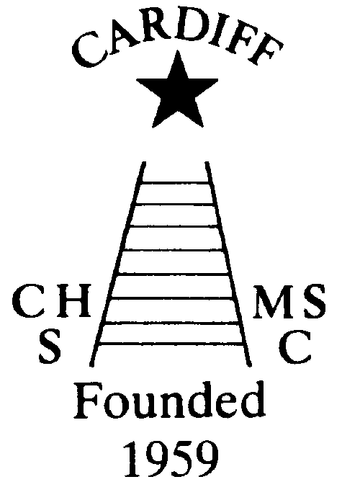
60 Years of
Achievement
Chameleons news 
The monthly newsletter of the Cardiff Chameleons
Volume 26: Issue 6: June 2019
Affiliated to:-Special Olympics GB, Special Olympics Wales, MENCAP,
Welsh Sports Association for People with Learning Disabilities.
Registered Charity No. 1103879
Website: www.cardiffchameleons.co.uk

1959

2019

60th Anniversary
Our anniversary meal takes place on the 15th of this month at St. Peter’s Hall in Roath. For those who are attending please note it is smart dress, no jeans etc., and arrival is from 7pm with a drinks reception and the meal starts at 7.30pm.
Here are some other events taking place during the year.
The Summer Afternoon tea will take place on Sunday July 7th from 2pm until 5pm and will be held at Howells school. See page 3 for full details!
Our Club swimming gala is going to be a little bit special too, as we are going to invite swimmers to join us from two local clubs, Bridgend Sharks and Swansea Stingrays, and this will be on Tuesday August 6th with the Presentation evening on Tuesday 13th. However, as St. Philip Evans hall is booked that evening, we are going to be at the Cardiff Medical Centre Sports & Social Club, on the Heath hospital site, the same room as the swimmers & bowlers had their Christmas disco.
So please try not to book your holidays over these dates.

Club Barbecue
This will be held on Sunday 1st September at Howells school, starting at 3pm. They is a problem with the swimming pool so there will be no swim session prior to the barbecue. Tickets cost £2 and available from the end of July.
Pamela has booked a coffee morning for Thursday 17th October at St. Philip Evans Hall from 10am – 12noon.Tickets will be on sale later in the year.
Chameleons Anniversary 1959 – 2019
Celebrate by buying / selling our new Flashlight Pen.
Ideal for the winter nights!
Only £1.50 each [OR 3 for £4.00 – Bargain!]
Please contact Elaine for your supply of pens.
Many Thanks Elaine Daw – Tel:02920 764770 elainemdaw@googlemail.com

60th Anniversary Hoodie
These have sold really well! The Hoodie is still available to order at £20.00 each and is intended to wear for leisure and not just for the swimmers or bowlers; anyone who is involved with the Club can buy one!! We will still order if you require one !
THANK YOU to those attended and who ordered the Club photograph. I was able to give the Club £112.00 towards funds. Stephen Bailey - Photographer
OTHER NEWS
“100” Club
The May winners are:- £20 Moya Rees , £10 Howard Ratcliff and £5 Louise Daw.
Congratulations!

GOOD LUCK! to the bowls team attending the competition up in Falkirk over 3rd – 7th June; and the tournament in Stroud on 12thJune. A busy time for them!

SWANSEA FESTIVAL
This is being held from Monday 8th to Thursday 11th July if you are interested in attending please contact Denise as soon as possible!

There are vacancies for the following positions for Special Olympics Wales
A Head of Delegation (HoD) and Assistant Head of Delegation (AHoD), an Organiser for the transport and somebody for kit selection / organising for the Welsh Team to go to the next National Summer Games to be held in Liverpool in 2021.
If interested please contact Jeff Savory on
jeff@specialolympicswales.co.uk

National Partnership Swimming Competition
This event is being held in Liverpool on Saturday 21st September. We will go up on Friday 20th and return on Sunday 22nd.
Please can Pamela have your name if you would like to attend by Friday 5th July as we will need to book accommodation etc. Cost will be available once we know how many are attending.

Yorkshire & Humberside are holding a Regional Gala in Harrogate on Saturday9th November. Any swimmers who would like to attend, please give your name to Pamela by Friday 20th September, as we will need to book accommodation etc.


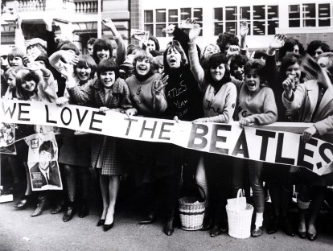

CARDIFF CHAMELEONS

SIXTIES SUMMER TEA PARTY

SUNDAY 7TH JULY AT HOWELLS SCHOOL

FROM 2PM TO 5PM

Tickets £3.50


Raffle & Bottle Stall

6o’s Music

Come dressed in 60’s Fashion and have your photo taken - Prize for the best!

Part of our 60th Anniversary Celebrations

Groovy baby!!



Bowls Group - The Schedule for 2019.
September 7/8 - Regional Bowls Competition Pembroke. More details to follow.
Any queries please speak to any of the coaching team. Margaret Krawiecha, Delyth Jenkins

Sandra Jones, Barrie Jenkins, Dave Medlam.

How to contact us
Pamela  (swim coach) | 2025 7314 | pamela.bailey6@virginmedia.com  Committee member
Robin  (swim coach) | 2021 8006
Barrie  (Bowls coach) | 2075 3038 | barriejenkins50@live.com  Committee Vice Chair
Elaine | 2076 4770 | elainemdaw@googlemail.com  Club Treasurer
Denise | 2075 2909 | Committee member
Ian | 2023 3065 | Committee member
Jane |  | Committee member
Heather |  | Committee member
Sandi / Pamela |  | Minute Secretary
Steve  (newsletter) | 2025 7314 | stephen.bailey497@ntlworld.com  Committee chair
Club Sessions
Swimming | Monday | Pentwyn LC 8pm – 8.45pm
Swimming | Tuesday | Eastern LC 8.30pm – 9.15pm
Bowls | Friday | Cardiff Indoor Bowls Club,  Sophia Gardens 4pm – 6pm
Any items for the newsletter need to be in 5 days prior to the end of the month. Please put them in a word document and as an attachment to the e-mail. Thank you.

