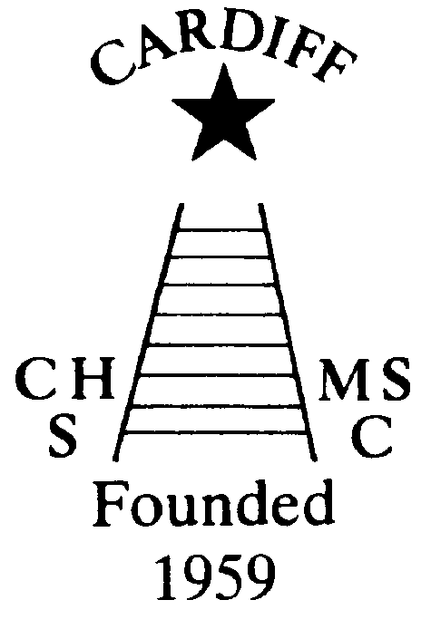
It is with deep regret and sadness that I have to announce the passing of Sally Anne Bourne on 16th August. She died of cancer which she had bravely fought. Details of Sally Anne’s funeral have slightly changed it is still to be held on Monday 3rd September but at 1.15pm and now in the Wenallt Chapel at Thornhill. Our thoughts and prayers are with her brother Christopher and his family and relatives at this sad time.
Chameleons’ news 
The monthly newsletter of the Cardiff Chameleons
Volume 25: Issue 8: September 2018
Affiliated to:-Special Olympics GB, Special Olympics Wales, MENCAP,
Welsh Sports Association for People with Learning Disabilities.
Registered Charity No. 1103879
Website: www.cardiffchameleons.co.uk

I have also heard of the passing of John Murphy in early August. John was the father of Kathryn Murphy, a former member of many years, again our condolences to Kathryn and family.

“100” Club
August winners were:-
£20.00 No. 25 Corrinne Mathias
£10.00 No. 37 Matthew Clark
£5.00 No. 17 Freda Bailey
The lucky winners have been notified. The next draw will be on the 15th September.
This will be the last draw for the year. If you wish to continue, or would like to join in, please send me your name and a cheque for £12 made payable to Cardiff Chameleons. You will be keeping the same numbers. If you do not cash your cheque and it has gone past the 6 months, no other cheque will be issued and the Club will keep the money. If we do not get enough people to run it to be profitable then I will return your payments and discontinue the 100 Club.

CLUB GALA / PRESENTATIONS EVENING
This was on Tuesday 7th August at Eastern LC. Fairly well attended but a lot of swimmers were missing. The event lasted just under an hour which is disappointing.
The Presentations evening went well with a very good turnout of support. Some of those who won the cups I took their photographs which can be seen on the website. The raffle raised £110.00. Thank you for the support!
Unfortunately, some cups / trophies could not be awarded as they have not been returned from previous galas. Please can you check that you do not have any in your home!

MEMBERSHIP RENEWAL
All members of the swimming and bowls need to renew their membership next month. The fee is £15.00 for the year. Please make payment to our Club treasurer- Mrs Elaine Daw, 11 St. Edeyrn’s Road, Cyncoed, Cardiff CF23 6TB.
Cheques made payable to Cardiff Chameleons.

It is September so CHRISTMAS comes to the fore!
Pamela is arranging a coach trip to the Christmas Market in Worcester. This will be on Saturday 1st December and is open to anyone and will cost £20.00 per person. Please give your name if you would like to go. It is an ideal way of doing some of your Christmas shopping.

Our usual Christmas Dinner and Dance is at St. Peter’s Hall, however, the hall was badly damaged in last winter’s heavy snowfall and is still under repair and we don’t know as yet what will happen. We will keep you informed.

A Christmas Disco for swimmers and bowlers is being arranged for Thursday 20th December at the Cardiff Medical Centre Sports & Social Club at the Heath
Hospital. Further information will be put out in due course

BOWLS
The Anniversary Games in Stirling Scotland. Celebrating Special Olympic GB's 40th Anniversary and Special Olympic World wide’s 50th Anniversary. Indoor Bowls was a late inclusion in the Anniversary Games which meant that only a small percentage of Welsh Bowlers was available for selection. Cardiff Chameleons Bowls section, based at Sophia Gardens, is the biggest club in Wales for people with Intellectual Learning Difficulties. Our numbers have increased considerably, following the success of the Welsh Bowlers at the National Summer Games in 2017 where a squad of 14 Bowlers came home with 20 medals. The club now numbers 25 bowlers with many more Welsh Bowlers based In West Wales at Pembroke Disability Bowls Club who have recently joined the Special Olympic Community, Carmarthen Region, Rhondda Cynon Taff etc.;
Eight Bowlers made the trip to Scotland. Shaun Peregrine from Ammanford. Naomi Baelz from St Athan, Paul Rogers - Cwmbran, Millie Campbell - Trealaw, Rhondda, Alan Beech, David Pratt, Robert Parker and James O'Brien all from Cardiff. The Welsh Bowlers competed against the best bowlers from the Scottish and English Special Olympic Regions and were successful in both the Singles and Pairs Competitions winning a total of 16 Medals. The team was accompanied by Barrie Jenkins Head Coach and Sandra Jones Assistant Coach from Cardiff Chameleons.
Singles Results.
Division 1a Naomi Baelz - Gold
Division 1b Shaun Peregrine - Gold
Division 2a Alan Beech - Bronze
Division 2b Robert Parker - Gold
Division 2c Paul Rogers - Gold
Division 2d David Pratt - Gold
Division 2d James O'Brien - Bronze
Division 2e Millie Campbell - Gold
Pairs Results.
Division A Shaun Peregrine & Naomi Baelz - Gold
Division B Alan Beech & Robert Parker - Bronze
Division C James O'Brien & Millie Campbell - Gold
Division C David Pratt & Paul Rogers - Silver.
The Competition was run by the same team who officiated at the Sheffield National Games in 2017 and a superb group of knowledgeable Volunteers, most of whom were present at the National Summer Games 2017. The competition was run professionally; it ran smoothly and to time and the bowlers enjoyed the company of their friends from other regions, the volunteers and the officials, some of them just did not want it to end

CARDIFF MENCAP CARAVAN
Fancy a week relaxing in west Wales? Then why not book the caravan which is situated in Penally just outside Tenby. Details of availability cost and bookings can be made through Denise Pearson on (029) 2075 2909

60th ANNIVERSARY
We will be celebrating 60 years as a Club next year and so we are looking for some ideas on how to celebrate it. A dinner is going to be held on June 15th at St. Peter’s Hall. We have thought of a Club photograph, a special gala and bowls competition and getting in some memorabilia such as pens. A sub-committee may need to be formed but if you have any ideas please contact me or another member of the committee.

PRIVACY
As you may know by now a directive came into force about what information on you can be held by a company or charity and if you still want that information to be held.
As we have information on each member of the Club, whether you have a learning disability, guardian / carer or a supporter i.e. your name, address, e-mail, telephone number, photo / video consent and some of you, your medical details, which you have consented to give. We do not share any of this information to a third party, unless it is for completion of competition forms, and would naturally ask you first if it ever arose.
Therefore, we are asking you now if you are now willing for us to keep this information on computer or paper copy.
If you do not want us to keep information about you, please let me or any committee member know by the end of September. If we do not hear from you by then we shall take it that you are happy for us to keep your information.

Moving on….
Many of you know that Pamela, John and I are in the process of moving house. It has not been an easy time.
We have to leave our current address as the buyer of our house wants to move in. Therefore with the move to our new house still not complete we are moving in with my mum. Therefore, after the 7th September we will no longer be contactable on our landline telephone number or by e-mail, so please use our mobile numbers, see the contact page on the back of this newsletter.
I will let you know when we are back up and running!

Good Luck to the swimmers who are attending 2 galas this month.
The first is the British Learning Disabilities Swimming Championships organised by MENCAP & Special Olympics in Swansea on September 1st and the second is the Bridgend Sharks Gala being held in Aberavon on the 8th.

How to contact us
Pamela  (swim coach) | 2025 7314 | pamela.bailey6@virginmedia.com  Committee member
Robin  (swim coach) | 2021 8006
Barrie  (Bowls coach) | 2075 3038 | barriejenkins50@live.com  Vice Chair
Elaine | 2076 4770 | elainemdaw@googlemail.com  Club Treasurer
Denise | 2075 2909 | Committee member
Ian | 2023 3065 | Committee member
Jane |  | Committee member
Heather |  | Committee member
Sandi |  | Minute Secretary
Steve  (newsletter) | 2025 7314 | stephen.bailey497@ntlworld.com  Committee chair
Club Sessions
Swimming | Monday | Pentwyn LC 8pm – 8.45pm
Swimming | Tuesday | Eastern LC 8.30pm – 9.15pm
Bowls | Friday | Cardiff Indoor Bowls Club,  Sophia Gardens 4pm – 6pm
Any items for the newsletter need to be in 5 days prior to the end of the month. Please put them in a word document and as an attachment to the e-mail. Thank you.
Articles submitted to the newsletter are included as written and are not subject to changes or necessarily the view of the editor.

