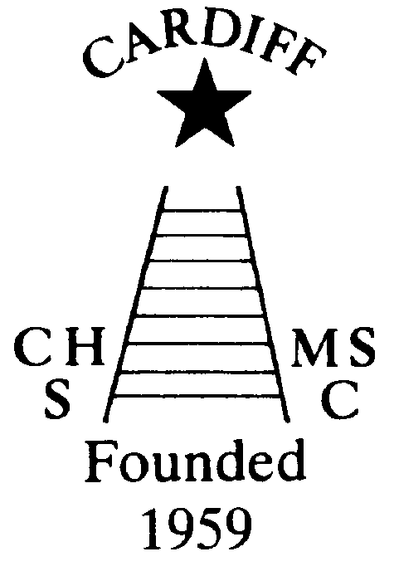
60 Years of
Achievement
Chameleons news 
The monthly newsletter of the Cardiff Chameleons
Volume 26: Issue 7: July 2019
Affiliated to:-Special Olympics GB, Special Olympics Wales, MENCAP,
Welsh Sports Association for People with Learning Disabilities.
Registered Charity No. 1103879
Website: www.cardiffchameleons.co.uk

1959

2019

60th Anniversary Celebration Dinner
This took place on the 15th June and went brilliantly well.
It started off with a glass of Bucks Fizz or orange juice on arrival at the hall. A memorabilia table was set up giving a history of the club with documents and many photographs.
Once everyone was seated we commenced by myself welcoming everyone and asked Keith Daw to say Grace and we then had our starters and main course.
A few speeches followed by Arthur Exton, who was a former chairman of the Club, giving us an insight of the Club in its early years, then by Dave Fowler who is our current President. This was followed by Wayne Crocker of MENCAP and a final one by Howard Davies of Cardiff Indoor Bowls Club.
We then had a special video message from Joyce Robinsons’ son David, who praised us on keeping the Club going as long as it has and said how proud his mother would be.
We then had our dessert course.
Two of our members, Teresa Pope and John Stafford got up and Teresa said a few words about the club and ended with a toast for the Club. This was followed by the cutting of the cake which was done by Kathleen Troughton, the daughter of Joyce with Teresa & John looking on.
Whilst coffee and tea was being served we had our final speech from myself which included a presentation I had made in tribute to all the athletes, parents and supporters who had passed away over the years and a speech which looked to the future and the importance of trying to get “younger people” involved in to help in running the Club and possibly reaching 70 years!!
The obligatory raffle then took place whilst Nick Palmer started the dancing to a wonderful variety of music from the 60’s and music that spanned the years including favourites of Club members past and present.
There are many people to thank for the preparation of the evening but will not mention any names as altogether it was a team effort - well done!! The raffle raised £196.00 so a thank you to all who bought tickets.

Here are some other events taking place during the year.
CANCELLED
The Summer Afternoon tea will take place on Sunday July 7th from 2pm until 5pm and will be held at Howells school. See page 6 for full details!
Our Club swimming gala is going to be a little bit special too, as we are going to invite swimmers to join us from two local clubs, Bridgend Sharks and Swansea Stingrays, and this will be on Tuesday August 6th with the Presentation evening on Tuesday 13th. However, as St. Philip Evans hall is booked that evening, we are going to be at the Cardiff Medical Centre Sports & Social Club, on the Heath hospital site, the same room as the swimmers & bowlers had their Christmas disco.
So please try not to book your holidays over these dates.
Club Barbecue
This will be held on Sunday 1st September at Howells school, starting at 3pm. There is a problem with the swimming pool so there will be no swim session prior to the barbecue. Please let us know if you are going to attend for catering purposes.
Pamela has booked a coffee morning for Thursday 17th October at St. Philip Evans Hall from 10am – 12noon.
Tickets will be on sale later in the year.
OTHER NEWS
NOTICE OF ANNUAL GENERAL MEETING
Notice is hereby given that the AGM will take place at Howells School, Cardiff road, Llandaff, Cardiff CF5 2YD on Wednesday 31st July commencing at 7.30pm.
All are welcome to attend.
“100” Club
The June winners are:- £20 Freda Bailey, £10 Christine Pope and £5 James Savory.
Congratulations!
There are vacancies for the following positions for Special Olympics Wales - A Head of Delegation (HoD) and Assistant Head of Delegation (AHoD), an Organiser for the transport and somebody for kit selection / organising for the Welsh Team to go to the next National Summer Games to be held in Liverpool in 2021.If interested please contact Jeff Savory on
jeff@specialolympicswales.co.uk
Meeting with Michelle Carney, CEO of SOGB
The Chepstow Suite at the Copthorne Hotel, Culverhouse Cross, CF5 6DH has been booked from 1pm – 4pm on Saturday 20th July. Can I ask regions to submit 2 or 3 questions prior to the meeting by Friday 12th July. There will also be time to ask questions from the floor and listen to Michelle’s Vision for the future of SOGB.
Jeff Savory OBE, SO Wales, 07803 165581

National Partnership Swimming Competition
This event is being held in Liverpool on Saturday 21st September. We will go up on Friday 20th and return on Sunday 22nd.
Please can Pamela have your name if you would like to attend by Friday 5th July as we will need to book accommodation etc. Cost will be available once we know how many are attending.
Yorkshire & Humberside are holding a Regional Gala in Harrogate on Saturday9th November. Any swimmers who would like to attend, please give your name to Pamela by Friday 20th September, as we will need to book accommodation etc.
SWANSEA FESTIVAL - This is being held from Monday 8th to Thursday 11th July good luck to those attending!
Bowls Group - The Schedule for 2019.
September 7/8 - Regional Bowls Competition Pembroke. More details to follow.
Any queries please speak to any of the coaching team. Margaret Krawiecha, Delyth JenkinsSandra Jones, Barrie Jenkins, Dave Medlam.

The Great Western Bowls Tournament 2019
The annual Great Western Bowls Tournament took place on Wednesday 12th June.
Cardiff Chameleons once again took 16 bowlers and several supporters to this tournament.
Apart from the driver getting lost again, the tournament went off without a hitch and our bowlers came home with both the Division 1 and the Division 2 trophies.
Cardiff Blues ( Robert Parker, David Williams, Millie Campbell and Naomi Baelz) once again dominated the tournament winning all their games, the only close game was the first, against Winsor Royals when they won by 2 shots.
Cardiff Chameleons topped their group in the first half of the competition but struggled in the Division 1 playoffs and finished fourth. Cardiff Exstra’s struggled in their first few games, but later found some form, winning their two remaining games in the Group playoffs, to win the Division 2 trophy.
Cardiff Reds were unfortunate to be drawn in Group A for Round 1, but did remarkably well beating Windsor Royals 7-4 in their last game. In Round 2 they were placed in Division 2 and did well to beat Isle of Wight Dolphins 7-4 to finish second in their Division.
All participants were presented with a medal to commemorate 30th years of the Great Western Bowls Tournament.
Our sincere thanks to Martin Stockwell and his wife for their dedication to bowlers with a Learning Disability and would like to wish them a happy retirement.

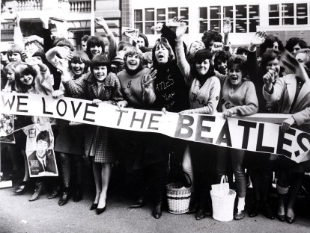

CARDIFF CHAMELEONS
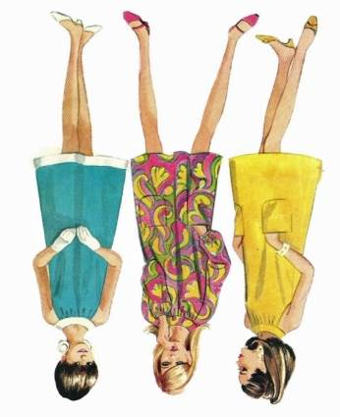
SIXTIES SUMMER TEA PARTY

CANCELLED
SUNDAY 7TH JULY AT HOWELLS SCHOOL


FROM 2PM TO 5PM

Tickets £3.50

Raffle & Bottle Stall
6o’s Music

Come dressed in 60’s Fashion and have your photo taken - Prize for the best!

Part of our 60th Anniversary Celebrations

Groovy baby!

How to contact us
Pamela  (swim coach) | 2025 7314 | pamela.bailey6@virginmedia.com  Committee member
Robin  (swim coach) | 2021 8006
Barrie  (Bowls coach) | 2075 3038 | barriejenkins50@live.com  Committee Vice Chair
Elaine | 2076 4770 | elainemdaw@googlemail.com  Club Treasurer
Denise | 2075 2909 | Committee member
Ian | 2023 3065 | Committee member
Jane |  | Committee member
Heather |  | Committee member
Sandi / Pamela |  | Minute Secretary
Steve  (newsletter) | 2025 7314 | stephen.bailey497@ntlworld.com  Committee chair
Club Sessions
Swimming | Monday | Pentwyn LC 8pm – 8.45pm
Swimming | Tuesday | Eastern LC 8.30pm – 9.15pm
Bowls | Friday | Cardiff Indoor Bowls Club,  Sophia Gardens 4pm – 6pm
Any items for the newsletter need to be in 5 days prior to the end of the month. Please put them in a word document and as an attachment to the e-mail. Thank you.

