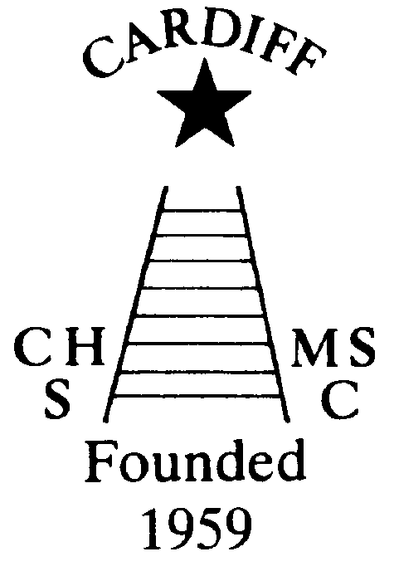
CHAMELEONS NEWS
The newsletter of the Cardiff Chameleons
Volume 28: Issue 03: April 2021

Affiliated to:-Special Olympics GB Special Olympics Wales, MENCAP,
Welsh Sports Association for People with Learning Disabilities.
Registered Charity No. 1103879 / WEBSITE: www.cardiffchameleons.co.uk

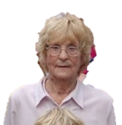
It is with regret …
That we have heard of the passing of Edna Alexander.
Edna’s son George was one of our swimmers and bowlers.
Edna would have been 98 this August. She was a loyal supporter of our fund-raising events.
We have sent our condolences to the family.

“50+” Club
Here are the winners for February
£15.00 Elaine Daw
£10.00 Peter Couzens

And here are the winners for March
£15.00 Simon Clark
£10.00 Peter Davey

The Club has earned £252.00 by the people who have re-joined this year.

Torquay Disabled Bowls Tournament – March 2021.
As you will be aware, hospitality venues are still closed.
I have been in touch with Torquay Leisure Resort, and they are planning to open on Saturday 4th July, 2021. Quote . . .
“All breaks before 4th July have been postponed. Please rest assured your money is safe. We are offering all customers the option to rebook another break anytime in the next 18 months.”
If possible we hope to transfer the booking to March 2022. For those that had booked, please confirm that you are happy with arrangement? Any queries or for further information, please contact Elaine – Tel: 02920 764770 or elainemdaw@googlemail.com
Thank you for your patience.

Pentwyn Leisure Centre
This, as some of you may know and possibly been to, is being used as a Mass Vaccination Centre (MVC). However, it has been reported (in the Echo) that the Cardiff Blues Rugby Club are taking over the running of the Centre. They are going to refurbish it including the swimming pool and it will be open to the public. However, whether we will be getting our spot is yet to be known.

Social Events ….Our social calendar may have some hope. We will try and put on an afternoon tea in June or July as it will be outdoors and hopefully good weather. Our Club gala may happen in August along with a Presentation Evening but this will depend on whether the Leisure Centre and hall venue are open and if larger amounts of people can meet.
Summer Barbecue has been arranged for the 29th August, provisionally, Sunday before the Bank Holiday weekend.
Naturally, Welsh Government guidelines will have to be taken into consideration for any of these to go ahead.

Belated birthday wishes to Christine Pope, Teresa’s mum, who was 80 towards the end of last month. Not sure if Chris wanted to keep this quiet but Teresa told us at our last swimmers zoom meeting!

Fundraising through Amazon….
Barrie has set up this to help fundraise for the Club…So if you shop with Amazon regularly please consider doing this.
When ordering please go through Amazon Smile.

A BIG THANK YOU to Neeta Joshi, who was Sally Anne Bourne’s carer up until Sally passed away, has donated £200.00 to the Club. Again thank you Neeta.

Return to bowling…
Our bowlers could possibly be returning on the 30th April. Barrie will no doubt be contacting you in the coming weeks about this.

The Cardiff & Vale Special Olympics Group had their AGM recently. The following people were re-elected en bloc.

Position held | Name
Chair | Pamela Bailey
Vice Chair | Barrie Jenkins
Treasurer | Pam Abbott
Main Contact (Secretary) | Jeff Savory
Voluntary Co-ordinator | Jeff Savory
Family Co-ordinator | Pam Abbott
Covid Co-ordinator | Barrie Jenkins
Sports & Competition Co-ordinator | Pamela Bailey
Sports & Competition Co-ordinator | Jeff Savory
Representative to SO Wales NEC | Jeff Savory
Representative to SO Wales NEC | Pamela Bailey
Committee Club Representatives
Representing Bridgend Sharks | Pamela Abbott
Representing Cardiff Chameleons Bowls | Barrie Jenkins
Representing Cardiff Chameleons Swimming | Pamela Bailey
Representing Golf | Ceri Lloyd
Representing Kayaking / Gymnastics | Jeff Savory
Representing Cardiff Shadows Badminton | Jeff Savory

Finally…
From me and on behalf of the Committee, I wish you a very Happy Easter.

How to contact us
Coaches | Pamela 029 2025 7314 / 07817 380355  pamela.bailey6@virginmedia.com | Robin  029 2021 8006 | Barrie 029 2075 3038  barriejenkins50@live.com
Treasurers | Elaine 029 2076 4770  elainemdaw@googlemail.com | Denise  029 2075 2909 | Ian  029 2023 3065
Newsletter | Steve 029 2025 7314 stephen.bailey497@ntlworld.com 33 Ty Cerrig Cardiff CF23 7DP  Items for the newsletter to be in 5 days before the end of the month and as a word attachment if sent by e-mail.
Locations | Swim sessions: Pentwyn LC: Monday 6.30pm – 7.15pm and Eastern LC Tuesday 8.30pm – 9.15pm
Locations | Bowls: Cardiff Bowls Club, Sophia Gardens: Friday 4pm – 6pm

