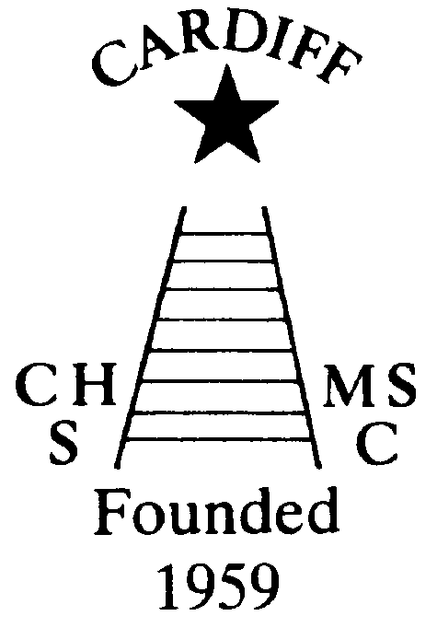
60 Years of
Achievement
Chameleon’s news 
The monthly newsletter of the Cardiff Chameleons
Volume 26: Issue 8: August 2019
Affiliated to:-Special Olympics GB, Special Olympics Wales, MENCAP,
Welsh Sports Association for People with Learning Disabilities.
Registered Charity No. 1103879
Website: www.cardiffchameleons.co.uk

1959

2019

It is with deep regret that I have to inform you that Louise Daw passed away at 5.30am on Wednesday 31st July at UHW. Her family were with her to the end.
I am sure that you will all join with me that our thoughts and prayers go to Keith, Elaine and family at this time.

CLUB GALA
Our Club swimming gala is going to be a little bit special this year, as we are going to invite swimmers to join us from two local clubs, Bridgend Sharks and Swansea Stingrays, and this will be on Tuesday August 6th with the Presentation evening on Tuesday 13th. We are going to be at the Cardiff Medical Centre Sports & Social Club, on the Heath hospital site, the same room as the swimmers & bowlers had their Christmas disco last year.
We also need any cups or trophies that you won last year and even the year before that returned to us by the 13th August. Please bring them back at a swim session or the evening of the gala.
DON’T FORGET this is the Club gala and all swimmers are entered and if you are a bowler who can swim then you’re welcome too. If you want to come and support you are welcome to come along. Competitors please note that you need to be at Eastern LC by 6.30pm to start at 7pm. If you are unable to attend the gala but would like to come to the Presentations a map showing the location for the Presentation evening is towards the back of this newsletter.
Here are some other events taking place during the year.
Afternoon Tea
This was due to have taken place last month but had to be cancelled at the last minute; which we apologise for but was beyond our control, however, we have rescheduled it for…
Sunday 18th August
…again it is to be held at Howells School from 2pm until 5pm. Tickets are now available and we have reduced the price to £3.00 entry. You can pay on the door but we would like to know if you are attending so that we can have some idea how many to cater for. We will provide the food and would like you to provide the drinks (alcoholic or soft).

Club Barbecue
This will be held on Sunday 1st September at Howells school, starting at 3pm. There is a problem with the swimming pool so there will be no swim session prior to the barbecue. Please let us know if you are going to attend for catering purposes.
Pamela has booked a coffee morning for Thursday 17th October at St. Philip Evans Hall from 10am – 12noon.
Tickets will be on sale in September.
OTHER NEWS
We are taking a break!
So, there will be no swim sessions on Monday 19th, Tuesday 20th, Monday 26th and Tuesday 27th August. We will return on Monday 2nd and Tuesday 3rd September.
The ANNUAL GENERAL MEETING
This took place at Howells School on 31st July and as it is too late to add into this newsletter we will let you know what came out of it next month.
“100” Club
The July winners are:- £20 – James O’Brien, £10 – Robin O’Donovan and £5 – Pauline Flynn. Congratulations!

Coming up next month…Renewal of membership forms will be given out ready for October and I will hopefully be able to let you know what we have lined up for Christmas!
National Partnership Swimming Competition
This event is being held in Liverpool on Saturday 21st September. We will go up on Friday 20th and return on Sunday 22nd. Date for names has now passed.
Pembrokeshire Puffins are holding a Gala in Milford Haven on Saturday 9th November. Any swimmers who would like to attend, please give your name to Pamela by Friday 20th September.
Bowls Group - The Schedule for 2019.
September 7/8 - Regional Bowls Competition Pembroke. More details to follow.
Any queries please speak to any of the coaching team. Margaret Krawiecha, Delyth Jenkins, Sandra Jones, Barrie Jenkins, Dave Medlam.

Good Luck to those attending the Bob Cooke games in Swindon on the 11th August.

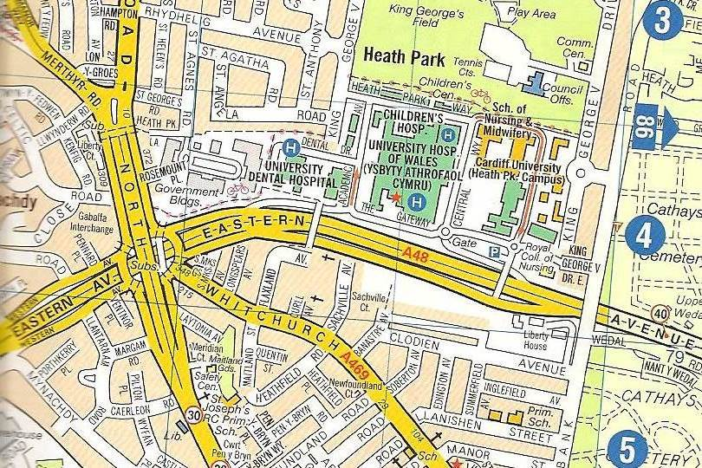
Cardiff Medical Centre
Sports & Social Club

