CONGRATULATIONS to Harry Scott who celebrates his 18th birthday this month. We hope you have a wonderful day!

Afternoon tea
This went really well and we had a good crowd and all had a good time. Although it was a nice sunny day, we were upstairs in the 6th form block. We raised £146.00 on the raffle. Thank you to Pamela and Rose for setting up the food and raffle. Ian for getting the venue prepared. I think the quiz I set was a bit too easy as it was very high scoring

Club photograph This photo-session went well although not all Club members attended, those who did will be getting their 65th year memento soon.

Our Annual Swimming Gala went really well at the pool in Howells school. With some swimmers not being able to attend we had fewer races and completed it under an hour. There were some really close races and all swimmers did well in showing their swimming ability. We now look forward to the Presentation of Cups & Trophies Ceremony - on the afternoon of Sunday 4th August in St. Philip Evans community hall, Llanedeyrn Drive (CF23 9UL). Please arrive at about 3pm and we will start at 3.30pm. As in previous years please can you bring a plate of food for the buffet and the bar will be available for drinks. We will hold a raffle of course!

HOWELLS SCHOOL There are no swim sessions during August. We will start again on Sunday 1st September.

CMC S&S CLUB on Thursdays from 8.00pm to 8.45pm and are on 1st and 8th. We will start again on Thursday 5th September.

Good Luck to the team attending the Bob Cook Games in Swindon on the 11th August.

SPONSORED SWIM IN AID OF THE CHAMELEONS
Last month I told you about the swim club at the Cardiff Medical Centre at the Heath Hospital did a sponsored swim to raise money for the Club. The total amount raised for us was £326.00 so a BIG THANK YOU to all the swimmers. We will present them with a certificate to mark this achievement when they start up again.

CHRISTMAS MARKET
Pamela is willing to organise a trip to a “local”, probably Gloucester Quays, Christmas market and so would like to know if there is any interest from any Club members. If there are enough people, we will also take some of our church parishioners who are interested to join us. We already have some members interested so if you do fancy the trip, please can you let Pamela know by the end of this month.

Plymouth Mayflower Games July 6/7th 2024
A successful weekend in Plymouth, as guests of the Mayflower Specials. Eighteen members, Coaches, Carers of Cardiff Chameleons Bowls team travelled down to Plymouth on Saturday morning July 6th, one small holdup on the M5 delayed our arrival by just 20 minutes. The afternoon session was very successful for most of our pairing across all divisions. Some notable performances on Day 1 were from Millie Campbell and Naomi Baelz, in Division A, Alan Beech and Robert Parker in Division A1, Gareth Howell and Garon Owen in Division B. The Team members continued their form on the divisional play on the Sunday morning, Naomi and Millie making it three wins on the trot.
There were wins for Alan Beech and Rob Parker, James O’Brien and Angus Pirrie, Ian Kelleher and David Williams. Two hard fought wins for Ben Lewis and Debra Pirrie on Sunday meant they finished strongly in their group, finishing in bronze medal position, nevertheless it was a good performance. The Saturday form of Gareth Howell and Garon Owen deserted them on the Sunday which meant they also finished in Bronze Medal position, Garon playing some of the best bowls of his career in my opinion! Naomi and Millie finished top in their group as did Alan and Robert. Their match on the Sunday afternoon playoffs was a hard-fought game, with Millie and Naomi (combined age of 68 years) taking the gold, Alan and Robert (combined age 129 years) taking Silver.
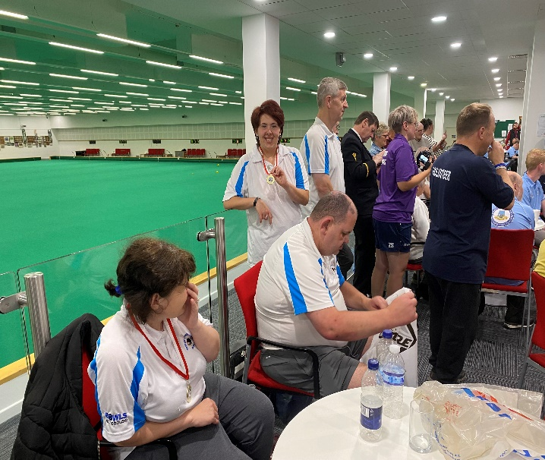
Ian Kelleher and David Williams finished second in their group, David being very consistent over the weekend, were up against, Rowland Crow and Chris Wilson from Plymouth. In a close fought match, the result was 8-6 in favour of the Plymouth pairing. Well done to all our bowlers, who all showed excellent form over the weekend and showed how strong the club is across the classifications and age ranges. (Barrie Jenkins)

James Savory also attended these games with the Cardiff Shadows Disability Badminton club. He won silver in the singles and a gold in the doubles with his partner Christopher Caulfield.

QUIZ TIME
Many of you know that at various social events I do a quiz. Well, I think it is about time I gave you a “brain teaser” each month,
So, for this month I am going to give you the following….

ESPR ESSO
I shall also give you a clue, “it is something you may have at about 11 o’clock in the morning”
Answer will be in next months newsletter. However, if you do know the answer and want to tell me just contact me, no prize though.
The answer to last months was: - CHAMELEON – (CAM-EEL-IAN). Well done to Heather and Laura Knight who managed to work it out between them and got in touch to see if they were right. Gold stars for them!
How to contact us
Coaches | Pamela – 029 2025 7314 / 07817 380355 pamela.bailey6@virginmedia.com
Coaches | Robin – 029 2021 8006
Coaches | Barrie – 07514 544619 barriejenkins50@live.com
Treasurer | Barrie Jenkins – 07514 544619 barriejenkins50@live.com  22 Heol Hir, Cardiff CF14 5AE
Newsletter  &  Chair | Steve – 029 2025 7314 / 07791 759360 / stephen.bailey497@ntlworld.com  Items for the newsletter to be in 5 days prior to the end of the month. Please put it as a Word attachment if on e-mail
Other contacts - Ian – 029 2023 3065 Denise – 029 2075 2909

