We are holding our annual “Afternoon Tea” at Howells school on Sunday 21st July from 2.30pm and the cost is £3.00 per person (pay on entry). We will be providing the food as usual and all we ask you to do is let us know that you are going to attend (so as we know how many to cater for) and to bring your own drink. We will have our usual raffle. There will not be a swim session in the evening.

Club photograph - I will take this before we start the afternoon tea, so all those athletes who will be there can you please wear your blue Chameleons polo shirt if you are a swimmer and your white Chameleons polo shirt if you are a bowler. If you want to, you can bring a top to change into for the afternoon tea. We have not done this since our 60th anniversary five years ago, so now we are 65 years we can have an updated one.
I had this idea and have cleared it with Barrie, the Treasurer, that the photograph will be given by the Club as a memento of our 65th anniversary. Each swimmer and bowler who is in the group photograph will then have a photograph taken on their own and the mount will have the group photograph and their photograph next to it.
An example will be available later to show you.

Our Annual Club Gala is going to be held on Sunday 28th July at the pool in Howells school. This is open to all swimmers, who will be put in the programme, if you will not be available on that day, please let Pamela know, if you can attend, please can you be at the pool by 5pm and we will start at 5.30pm and should be finished by 7pm.
We therefore, now need you to start returning the cups and trophies you won last year, preferably engraved with your name and year (2023) as it will not be recorded on the cup/trophy otherwise.

The Presentation of Cups & Trophies Ceremony - We held this last year in the afternoon and as it was very successful, we are going to do it again on the afternoon of Sunday 4th August in St. Philip Evans community hall, Llanedeyrn Drive (CF23 9UL). Please arrive at about 3pm and we will start at 3.30pm. As in previous years please can you bring a plate of food for the buffet and the bar will be available for drinks. We will hold a raffle of course!
There will not be a swim session at Howells school in the evening.

Welcome back to Martyn Nethercot who has been coming to swimming for a few weeks now and we are glad that he is enjoying it and back with his friends.

JUNE SWIM SESSIONS

HOWELLS SCHOOL on Sundays from 6.00pm to 6.45pm and are on the 2nd, 9th,16th, 23rd and the30th.

CMC S&S CLUB on Thursdays from 8.00pm to 8.45pm and are on 6th ,13th, 20th and the 27th.

Well done to the swimmers who went off to Liverpool for the Special Olympics North West Regional Gala, hosted by the Cheshire Penguins. All did very well and came away with a medal.

The Bob Cook Games are being held in Swindon on Sunday 11th August. If you wish to attend, please give your name to Pamela asap.

Good Luck to the bowlers who are attending the Great Western Bowls Tournament in Stroud on the 12th, and the Outdoor Welsh Triples and Pairs on the 16th and 23rd June at the Cardiff Indoor Bowls Club.

QUIZ TIME
Many of you know that at various social events I do a quiz. Well, I think it is about time I gave you a “brain teaser” each month,
So, for this month I am going to give you the following….

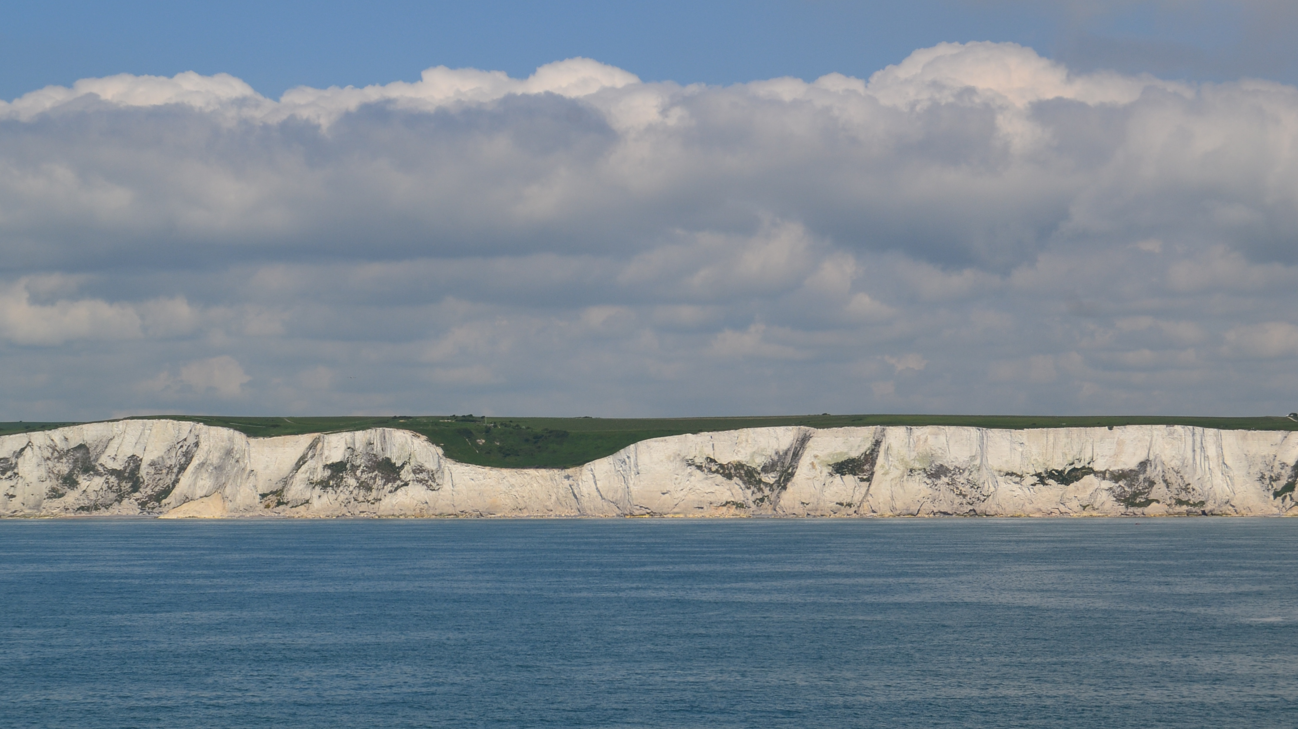
CARDIFF CITY F.C.

I shall also give you clue, it is “A well-known song”

Answer will be in next months newsletter. However, if you do know the answer and want to tell me just contact me, no prize though.
The answer to last months was: - twelve = signs of the Zodiac.

How to contact us
Coaches | Pamela – 029 2025 7314 / 07817 380355 pamela.bailey6@virginmedia.com
Coaches | Robin – 029 2021 8006
Coaches | Barrie – 029 2075 3038 / 07514 544619 barriejenkins50@live.com
Treasurer | Barrie Jenkins – 029 2075 3038 / 07514 544619 barriejenkins50@live.com  22 Heol Hir, Cardiff CF14 5AE
Newsletter  &  Chair | Steve – 029 2025 7314 / 07791 759360 / stephen.bailey497@ntlworld.com  Items for the newsletter to be in 5 days prior to the end of the month. Please put it as a Word attachment if on e-mail
Other contacts - Ian – 029 2023 3065 Denise – 029 2075 2909

