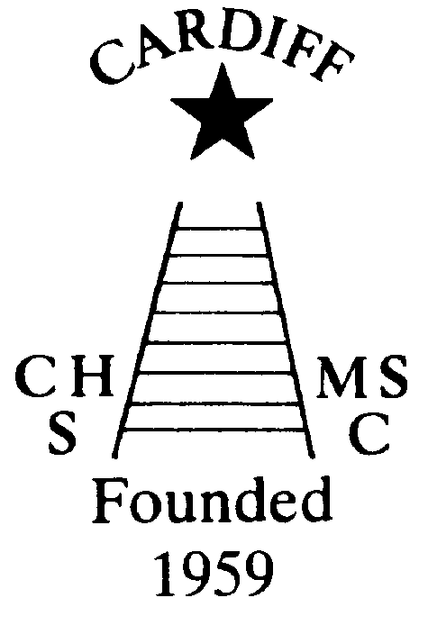
CHAMELEONS NEWS
The Monthly newsletter of the Cardiff Chameleons
Volume 27: November 2020

Affiliated to:-Special Olympics GB Special Olympics Wales, MENCAP,
Welsh Sports Association for People with Learning Disabilities.
Registered Charity No. 1103879 / WEBSITE: www.cardiffchameleons.co.uk

Hello everyone! Hope all is good with you?

“50+” Club
As promised I have been doing the draws each month and the following are the lucky ones!
September winners are £15 – Eve Pearson #32; £10 – Freda Bailey #36
October winners are £15 – #29 Ann Minchin; £10 – #53 Owain Davies
We are going to continue with this next year, so I am giving you (very) early notice that payment of £12.00 will need to be with me by Friday 18th December. The prize money will stay the same.
New players welcome!!!
Steve. (Contact details below)

RENEWAL OF CLUB ANNUAL SUBSCRIPTIONS – OCTOBER 2020 to SEPTEMBER 2021
At a recent committee meeting, it was decided to revise the amount of Annual Subs due in October. As the activities of the club have been curtailed [because of Covid-19] for approx. six months, the amount due on 1st October has been reduced to £10 [usually £20].
If all goes to plan, we hope to commence swimming/bowls in the near future and the Annual Subs of £10 will be collected either via the coaching staff or directly to Mrs. Elaine Daw, 11 St. Edeyrns Road, Cardiff CF23 6TB. Cheques made payable to Cardiff Chameleons. Thank You.
If you have yet to pay please do so as soon as possible.

Annual General Meeting
Our Annual General Meeting was held 21st October but as a zoom meeting, this is a first for the Club. The committee was re-elected en-bloc plus we have new committee member so I would like to welcome Dr Asif Alam, father of Omar, one of our swimmers, to the committee.
Our finances are still in the black, however fundraising is still being missed, the Co-op has finished but another scheme is available and details are further on in the newsletter.

CHRISTMAS MEAL
As we do not know what the situation will be like by Christmas and what we can and cannot do, so regretfully, I have had to cancel the dinner; but I will rebook for next year and hope that the restrictions will be less severe.

Swimmers - Pamela would like to hold a zoom meeting with you to have a chat and to see you all. If you are able to do this can you please contact her on pamela.bailey6@virginmedia.com or text / call on 07817 380355 and she will then put out some dates to arrange one for mid-November and then hopefully have another one in December.

CO-OP Local Community Fund
Barrie set us up to get money from the Co-op and if you joined the scheme and spent money at a store we would get a share of the total when it stopped.
Well he wants to thank those who did as our share of the total is….£2393.00.

We wish a speedy recovery to Alan Beech who has recently had an operation on his ear.

Bowls: Barrie hopes that sessions will restart on Friday 13th November.

Torquay Weekend Friday 26th March to Sunday 28th March 2021.
As many of you are aware, our payment for the Torquay Bowls Tournament 2020 has been credited to next year due to Covid-19.
If your names were included in this event, please can you confirm that you will be attending in 2021. Also, if your name was not included, but you would like to attend next year, please let me know?
There is a small increase in cost. However, depending on numbers, we hope this amount will be absorbed by the club. More information will be shared when it becomes available.
Elaine – 02920 764770 – elainemdaw@googlemail.com

Fundraising through Amazon….
Barrie has set up this to help fundraise for the Club…So if you shop with Amazon regularly please consider doing this.

Welcome to AmazonSmile!

Thank you for supporting Cardiff Chameleons Mencap/ Gateway Swimming Club.

Remember, always start at smile.amazon.co.uk
and Amazon will donate 0.5% of the net purchase price (excluding VAT, returns and shipping fees) to the eligible charitable organisation of your choice.

How to make the most of AmazonSmile
Install Amazon Assistant
The easiest way to return to smile.amazon.co.uk. Available for:

Share smile.amazon.co.uk with your friends:

How to contact us
Coaches | Pamela 029 2025 7314 / 07817 380355  pamela.bailey6@virginmedia.com | Robin  029 2021 8006 | Barrie 029 2075 3038  barriejenkins50@live.com
Treasurers | Elaine 029 2076 4770  elainemdaw@googlemail.com | Denise  029 2075 2909
Newsletter | Steve 029 2025 7314 stephen.bailey497@ntlworld.com 33 Ty Cerrig Cardiff CF23 7DP  Items for the newsletter to be in 5 days before the end of the month and as a word attachment if sent by e-mail.
Locations | Swim sessions: Pentwyn LC: Monday 6.30pm – 7.15pm and Eastern LC Tuesday 8.30pm – 9.15pm
Locations | Bowls: Cardiff Bowls Club, Sophia Gardens: Friday 4pm – 6pm

