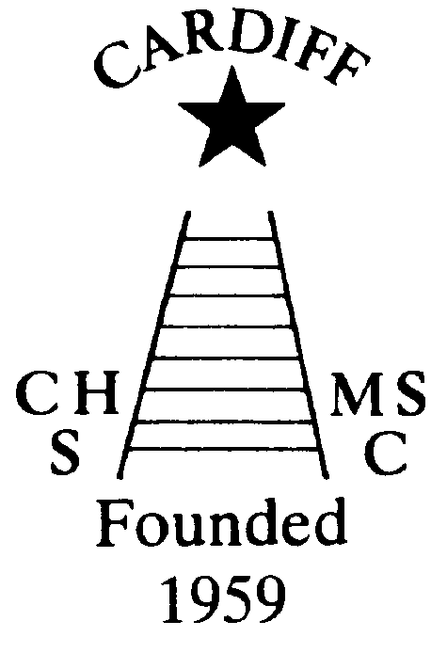
CHAMELEONS NEWS
The newsletter of the Cardiff Chameleons
Volume 28: Issue 01: February 2021

Affiliated to:-Special Olympics GB Special Olympics Wales, MENCAP,
Welsh Sports Association for People with Learning Disabilities.
Registered Charity No. 1103879 / WEBSITE: www.cardiffchameleons.co.uk

Hello everyone! Hope all is good with you? Sorry there wasn’t a newsletter last month but the three of us were in isolation all over Christmas as Pamela tested positive, probably me too but I never got a result and by which time the isolation period had gone. We don’t think John had it but he had to be shielded and I didn’t feel up to doing anything. It was not a nice position to be in.
Any way a few things did happen….
….Pamela had a zoom meeting with the swimmers and was pleased that about 10 members joined us. Pamela hopes to have more.

Pamela and Rob visited Eastern Leisure Centre and there was just a chance that we could have been back there around mid – January but being put straight into lockdown again scuppered those plans. However, ideas were said and when we are able to go back we will be in touch with the swimmers and parents.

“50+” Club
Here are the first winners for this year..
£15.00 Rose Marshall No.51
£10.00 Teresa Pope No.9
The Club has earned £252.00 by the people who have re-joined this year.

Due to Covid-19 fundraising has been difficult to do; the following is from Elaine our treasurer…

…It has been a difficult year for everyone, not least our club.
Despite not being able to meet for swim/bowls sessions we have been unable to organize fund raising events.
As many of you know, we received a cheque for £2,123 from the Co-op Good Causes Campaign. We are grateful to Barrie for organizing this.
In these lockdown days, we hope you are using ‘Smile Amazon’ to purchase items on line to support Cardiff Chameleons. Remember, always start at smile.amazon and Amazon will donate 0.5% of the net purchase to the eligible charitable organization of your choice. Please make sure you have inserted Cardiff Chameleons as your chosen charity.
However, we are grateful to have some loyal patrons who have given donations to the club over the past few months.
Cardiff Bowling Club £500
Tennant Lodge £50
David Robinson £250
Marilyn Jenkins [in lieu of preserves] £50
Arthur Exton [Pen Fund Raiser] £515
In memory of Wyndham Williams £280
[Husband of Anne Williams and father of Andrew Williams]
Croeso Lodge £250
Hilary Holtam £100
We are extremely grateful to those who have made donations and we hope to be in a position to purchase a ‘newer’ more reliable minibus in the near future.
Thank you all.
Elaine Daw – Treasurer 27.01.21.

Did you know….?
That you can read the newsletter on our website too! The address is in the header on the newsletter.

Social Events
Our social calendar may have some hope. We will try and put on an afternoon tea in June or July as it will be outdoors and hopefully good weather. Our Club gala may happen in August along with a Presentation Evening but this will depend on whether the Leisure Centre and our church hall are open and if larger amounts of people can meet.
Summer Barbecue has been arranged for the 29th August, provisionally, Sunday before the Bank Holiday weekend.
Naturally, Government guidelines will have to be taken into consideration for any of these to go ahead.

Have you any photos of the Clubs activities from days gone by or of recent times?
Emily Burnett is presently digitalising photos to ensure that we have a lasting photographic history of the Club. Have you any photographs that show the activities or people of the Club?
If you do, please let me know and I will get Emily or Sandi to contact you.

Special Olympics GB Fees increase
We are not saying too much about this as it doesn’t involve the Club as a whole and is an ongoing situation. Pamela is attending another meeting on Thursday 4th February. However, it will affect those members who are swimmers and bowlers who go away to attend Special Olympic events. Pamela will be discussing this situation with the swimmers and Barrie will do the same with the bowlers.

Future Newsletters
I will be doing the newsletter only if there is information we need to let you know about. As I have said many times before, if you have anything you want to share with the Club, please let me know.
By the way this is my 28th year doing the newsletter and I have still got all the early issues when I did them on a typewriter! If you’re too young to know what a typewriter is then ask your parents!!

How to contact us
Coaches | Pamela 029 2025 7314 / 07817 380355  pamela.bailey6@virginmedia.com | Robin  029 2021 8006 | Barrie 029 2075 3038  barriejenkins50@live.com
Treasurers | Elaine 029 2076 4770  elainemdaw@googlemail.com | Denise  029 2075 2909
Newsletter | Steve 029 2025 7314 stephen.bailey497@ntlworld.com 33 Ty Cerrig Cardiff CF23 7DP  Items for the newsletter to be in 5 days before the end of the month and as a word attachment if sent by e-mail.
Locations | Swim sessions: Pentwyn LC: Monday 6.30pm – 7.15pm and Eastern LC Tuesday 8.30pm – 9.15pm
Locations | Bowls: Cardiff Bowls Club, Sophia Gardens: Friday 4pm – 6pm

