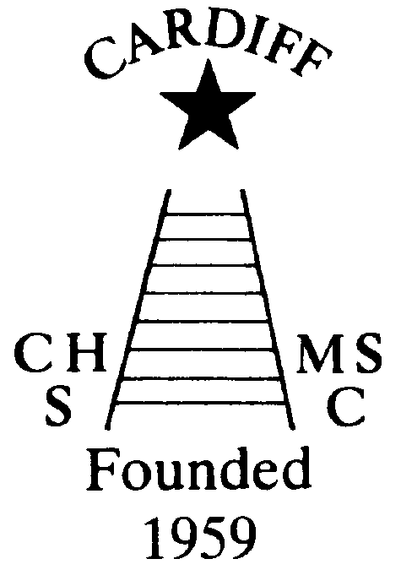
CHAMELEONS NEWS
The Monthly newsletter of the Cardiff Chameleons
Volume 27: December 2020

Affiliated to:-Special Olympics GB Special Olympics Wales, MENCAP,
Welsh Sports Association for People with Learning Disabilities.
Registered Charity No. 1103879 / WEBSITE: www.cardiffchameleons.co.uk

Hello everyone! Hope all is good with you?

Well here we are at the end of a very extraordinary year! A year, that has hit us badly, in respect of training, competition and even more so in the social aspect of the Club’s life. We couldn’t have our afternoon tea and it was a glorious summer, our Gala and presentation evening and also our Christmas celebrations have had to be cancelled. Our barbecue though did survive.
Of course fund-raising was hit too! We couldn’t have our coffee mornings but Barrie had come up with the CO-OP Local Community Fund which we received a good sum of money from; and now Amazon Smile, which we would like you to do if you are a regular buyer with Amazon.
However, our bowlers have been able to restart, although they will have restrictions to comply with; and some good news for swimmers though, Pamela has been in touch with Eastern Leisure Centre and there is just a chance that we could be back there around mid – January as long as there isn’t another lockdown due to people being silly over Christmas. Pamela is going to meet with the manager soon, so she will let all the swimmers know what arrangements will be put in place in due course.

“50+” Club
As promised I have been doing the draws each month and the following are the lucky ones!
I have brought forward the December draw and did a double draw last month
November winners are £15 – Bryn Owen #40; £10 –Gill Bourne #21
December winners are £15 – Vicky Pearson #31; £10 – Angela Young #55
We are going to continue with this next year, I will need the payment of £12.00 (plus your address) to be with me by Friday 18th December. The prize money will stay the same*
New players welcome!!!
Steve. (Contact details overleaf)
*depending on the number of players

CONGRATULATIONS to Teresa Pope who last month retired from M&S after 28 years of service at their store in Culverhouse Cross. As she has been unable to work there since March due to this virus, her colleagues didn’t want her to miss out so a couple of them made a socially distanced call to Teresa’s home and gave her a card signed by the staff and present.

RENEWAL OF CLUB MEMBERSHIP….These should have been paid by now, if you haven’t, please send it directly to Mrs. Elaine Daw, 11 St. Edeyrns Road, Cardiff CF23 6TB. Cheques made payable to Cardiff Chameleons. Thank You.

CHRISTMAS MEAL
Regretfully this has been cancelled.

Fundraising through Amazon….
Barrie has set up this to help fundraise for the Club…So if you shop with Amazon regularly please consider doing this.
When ordering please go through Amazon Smile.

And finally …May I to the committee and on behalf of the committee wish you all to keep safe and have a very Merry Christmas and a Happy New Year!

How to contact us
Coaches | Pamela 029 2025 7314 / 07817 380355  pamela.bailey6@virginmedia.com | Robin  029 2021 8006 | Barrie 029 2075 3038  barriejenkins50@live.com
Treasurers | Elaine 029 2076 4770  elainemdaw@googlemail.com | Denise  029 2075 2909
Newsletter | Steve 029 2025 7314 stephen.bailey497@ntlworld.com 33 Ty Cerrig Cardiff CF23 7DP  Items for the newsletter to be in 5 days before the end of the month and as a word attachment if sent by e-mail.
Locations | Swim sessions: Pentwyn LC: Monday 6.30pm – 7.15pm and Eastern LC Tuesday 8.30pm – 9.15pm
Locations | Bowls: Cardiff Bowls Club, Sophia Gardens: Friday 4pm – 6pm

