Belated congratulations to Jason Yeo who celebrated his 50th birthday last month. We hope you had a wonderful day!

Martin Nethercot gets a birthday this year too!

Do you have a special birthday or celebration this year? Please let me know when it is and I’ll put it in the newsletter.

FEBRUARY SWIM SESSIONS

HOWELLS SCHOOL on Sundays from 6.00pm to 6.45pm and are on the 4th ,11th, 18th and 25th
.
CMC S&S CLUB on Thursdays from 8.00pm to 8.45pm and are on 1st ,8th, 15th ,22nd and 29th

DENISE PEARSON
Denise has had a short stay in hospital last month after feeling unwell. However, she is now feeling a lot better and is back home.

A BIG THANK YOU to Annabel & John Foulston who have donated £1,000.00 to the Club. Annabel is lifelong friend of Denise and has given donations over the years.

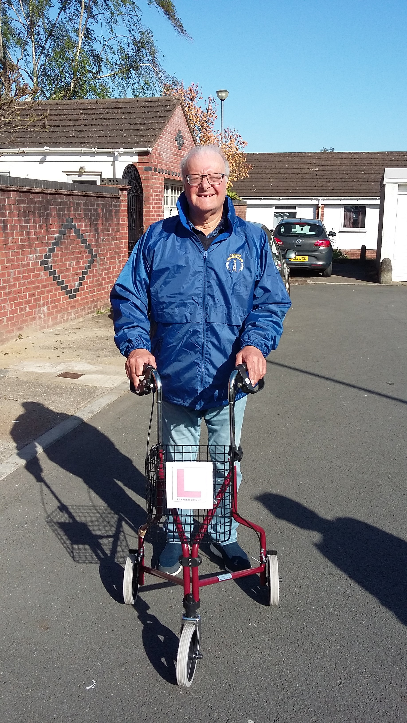
.
FREE TO A GOOD HOME
Tri-walker, in good condition,
red in colour,
comes with a bag and a basket,
one careful owner.
(John optional)

Contact Pamela or Steve.

Welcome to the Club!

Our new member is Harrison and he joins us at the Sunday sessions at Howells, along with his dad, Andrew, who helps him in the water.

Pamela is going to do an EASTER RAFFLE as a fundraiser. Raffle tickets can be bought from Pamela at swim sessions and from Barrie at bowls sessions from mid- February, anyone-else who is interested in buying tickets can contact us, and the draw will be made on Sunday 17th March. The first prize is a “chocolate” hamper with supporting prizes of easter goodies. Tickets are the usual £1 per strip.

Special Olympics Membership
Barrie has asked to remind you that those who want to attend Special Olympics events please can you pay £23.00 to him by cash or pay directly into our account.

Last month we had to cancel a swim session at the CMCS&S. Although we contacted most people by phone and by e-mail, we did miss a couple of people, for which I apologise.
I have now updated the e-mail list and everyone should now be listed.
I always ask for you to acknowledge that you have received the message, I know some do but there are some who don’t. Also, it would be ideal if you replied at the time, you read it.
This is also a good time to remind you if you do have a change of contact details, please let me know!
Rant over.

Many of you know that at various social events I do a quiz. Well, I think it is about time I gave you a “brain teaser” each month, So, for this month I am going to give you the following….
BLANKFILLBLANK

I shall also give you clue, it is “a well-known saying”. Answer will be in next months newsletter. However, if you know the answer and want to tell me just contact me, no prize though.

How to contact us
Coaches | Pamela – 029 2025 7314, 07817 380355 pamela.bailey6@virginmedia.com
Coaches | Robin – 029 2021 8006
Coaches | Barrie – 029 2075 3038 / 07514 544619 barriejenkins50@live.com
Treasurer | Barrie Jenkins – 029 2075 3038 / 07514 544619 barriejenkins50@live.com  22 Heol Hir, Cardiff CF14 5AE
Newsletter  &  Chair | Steve – 029 2025 7314 / 07791 759360 stephen.bailey497@ntlworld.com  Items for the newsletter to be in 5 days prior to the end of the month. Please put it as a Word attachment if on e-mail
Other contacts - Ian – 029 2023 3065 Denise – 029 2075 2909

