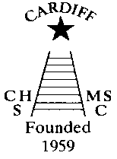
CHAMELEONS NEWS
The monthly newsletter of the Cardiff Chameleons
Affiliated to: MENCAP / Welsh Sports Association / Special Olympics GB /
Special Olympics Wales /Welsh Sports Association for People with a
Learning Disability
Website: www.cardiffchameleons.co.uk
Registered Charity Number 1103879
VOLUME 30 - ISSUE 03 – MARCH 2023

CONGRATULATIONS!
To James Savory who celebrates his 40th birthday this month, have a wonderful day!
EASTER RAFFLE
Pamela is organising this as a fundraiser for the Club.
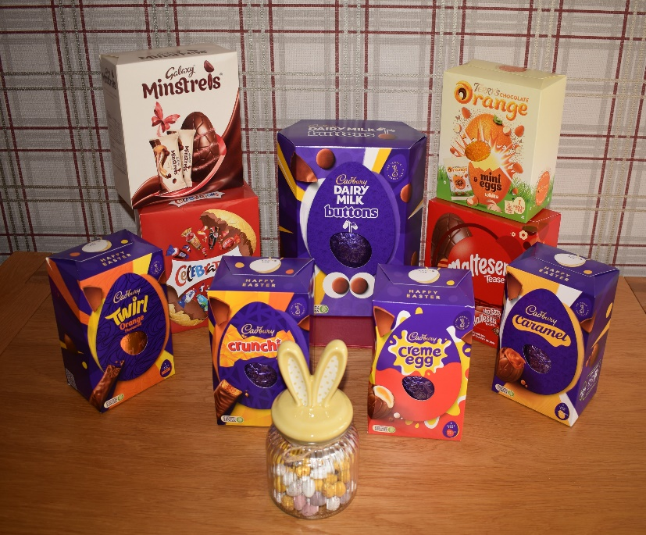
Starting from Thursday 2nd March, tickets will be available to buy at swim sessions at the CMC S&S Club and at Howells school; and Barrie will be selling tickets at the Bowls sessions each Friday up until the draw date which will be on Sunday 26th March. If anyone else would like to buy tickets, then please contact Pamela (see contact numbers at the end of the newsletter) and send us a cheque or by BACS for the amount you wish to spend, they are the usual £1 per strip, and we will keep your tickets for you (or try and get them to you) and enter them into the draw. All winners will be notified.
Pictured are the prizes with the one at the middle of the back row being the main prize.

EASTER BREAK
The swimmers are taking a break! There will be no swimming on Thursday 6th April and Sunday 9th April. We will return on the 13th and 16th.
The bowlers won’t be meeting on Friday 7th April.

SWIM SESSIONS
HOWELLS SCHOOL sessions for March are on Sunday 5th,12th,19th and 26th.
There is now only one session and that is from 6.15pm to 7.00pm.
For our beginners and novices, their session will be for half an hour from 5.45pm – 6.15pm.
PLEASE NOTE: Due to work being carried out within the school grounds sessions may be cancelled. We will endeavour to let you know as soon as we can if this happens.
CMC S&S CLUB - the sessions for March are on Thursday 2nd,9th,16th and 23rd.

Please let Pamela know if you cannot attend a session

FORTHCOMING SWIMMING GALAS
We have the following galas coming up soon.
There is a gala being run by Swansea Stingrays on Saturday 20th May which is just a day event.
The Special Olympics North West Regional Gala (hosted by the Cheshire Penguins) is on Saturday 17th June. So, we will be going up on the Friday (16th) and return on the Sunday (18th).
If you wish to attend either or both of these events then please contact Pamela as soon as possible so that we can make the arrangements.

BOWLS SESSIONS & Competition news
Cardiff Indoor Bowls Club every Friday.
GOOD LUCK! To the bowlers as they are off to Torquay on the 24th – 26th March.
Then they are going up to Yorkshire from the 25th – 28th April for the LDIBIS competition.
And then, in the summer to the Great Western Bowls tournament on the 7th June.

CLUB SUBSIDY
At our last Committee meeting it was decided that the Club would re-instate a subsidy when attending an event which means an overnight stay.
Therefore a £10.00 subsidy, per person per night and will be given to athletes and coaches only when attending an event which has overnight stays. This will apply to both the swimming and bowls groups.

2024
Next year, we will be celebrating our 65th anniversary. We are looking into ways on how to celebrate this event. Have YOU an idea on how we can celebrate it throughout the year! We have decided to start on this now as this is going to take time to organise.

TOTE & JUTE BAGS
We have a supply of Tote Bags and Jute Bags which have the Club Logo on the side which we are selling at £2.50 and £4.00 respectively. Handy as shopping bags which are light and strong. Ideal as gifts. These are available by contacting Pamela.

PAYING MONEY TO THE CLUB?
To avoid paying bank charges on cash and cheques when paying any monies to the Club please try and do it by bank transfer, the details are…
Bank: HSBC – Account name – Cardiff Chameleons – Sort Code 40-16-30 Account Number 01431285
It would also be helpful if you could add your surname and/or reason for payment e.g., Membership.
Many thanks for your help.

How to contact us
Coaches | Pamela – 029 2025 7314  07817 380355 pamela.bailey6@virginmedia.com
Coaches | Robin – 029 2021 8006
Coaches | Barrie – 029 2075 3038 barriejenkins50@live.com
Treasurer | Barrie Jenkins – Details as above.
Newsletter  &  Chair | Steve – 029 2025 7314 / 07791 759360 stephen.bailey497@ntlworld.com  Items for the newsletter to be in 5 days prior to the end of the month. Please put it as a Word attachment if on e-mail
Other contacts | Ian – 029 2023 3065  Denise – 029 2075 2909
Club sessions
Swimming - Howells School – Sunday 5.45pm – 6.15pm (novices) and 6.15pm – 7.00pm.
Cardiff Medical Centre Sports & Social Club (UHW site) – Thursday 8.00pm – 8.45pm
Bowls – Cardiff Indoor Bowls Club –
Friday 4.00pm – 6.00pm.

