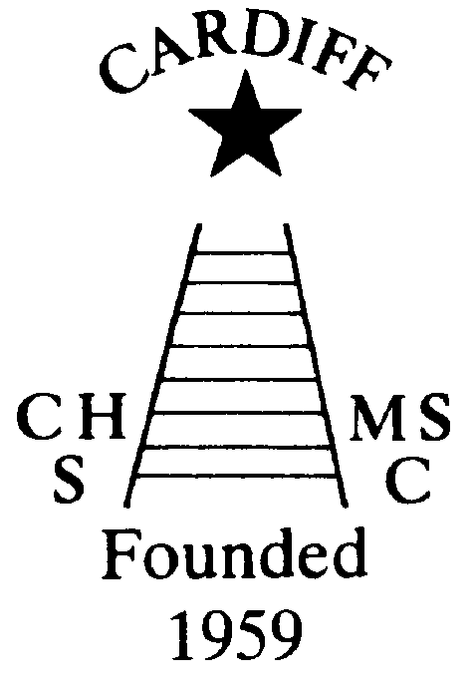
60 Years of
Achievement
Chameleon’s news 
The monthly newsletter of the Cardiff Chameleons
Volume 26: Issue 11: November 2019
Affiliated to:-Special Olympics GB, Special Olympics Wales, MENCAP,
Welsh Sports Association for People with Learning Disabilities.
Registered Charity No. 1103879
Website: www.cardiffchameleons.co.uk

1959

2019

MEMBERSHIP RENEWAL
Last month you needed to renew your membership, forms have already been given out and membership is now £20.00 for the year. Please return them to our treasurer Elaine to the address on the form or to Pamela, Denise or Barrie. If you have not yet renewed your membership please do so as soon as possible as you will not be able to attend your swim / bowls sessions!
Swim session fees are now £3.00 per session.
COFFEE MORNING
A good attendance at this event as some even came from our church! We raised on the day £283.50 for the Club which is a very good amount. Since then we received some donations bringing the total to an amazing £306.50.
****OTHER NEWS****
“100” Club - The October winners are:-
£20 - Peter Davey, £10 – Ian Marshall and
£5 - Moya Rees. Congratulations!
Special Olympics National Summer Games 2021
Liverpool - These are being held from Tuesday 3rd August until Sunday 8th August 2021. Any swimmer who wishes to attend please can you let Pamela know as soon as possible.
PODS Pantomime – They are putting on a performance of “Aladdin” and we are arranging to go and see this on Thursday 5th December. If you are interested please contact Denise.
WELCOME TO… Dewi and Helen…they are two volunteers and are helping out at our swim sessions. Dewi attends on a Monday and Helen on Tuesday.

Torquay Disabled Bowls Tournament – Friday 27th March to Sunday 29th March 2020.
We are planning to go to Torquay again next year.
We shall leave Cardiff on Friday 27th March in the morning [time and venue to be confirmed] and return late afternoon on the Sunday 29th March. I need to have names and deposits as soon as possible to secure the rooms.
Please be aware that there is another Bowls competition in Plymouth the following weekend 3rd to 5th April. You are welcome to attend both if you so wish.
However, if you wish to attend the Torquay Weekend, please give your name and £50 deposit to Elaine elainemdaw@googlemail.com or Tel. 20764770 as soon as possible.
Letters to follow. Thank You. Elaine

GOOD LUCK…to the swimmers attending the Pembrokeshire Puffins gala in Haverfordwest on Saturday 9th.

A BIG thank you - to some of the bowlers who have been doing bucket collections recently at, ASDA, MORRISONS and SAINSBURYS, collecting a total of £1415.00 for the Club.

The Vision 21 Christmas Food + Craft Fair is being held between 10.00 am & 2.00pm on Friday 29th November at Sbectrwm , Bwlch Road Fairwater CF5 3FF . Entry is 20p
The Hijinx Odyssey Christmas Show is called
“The Curious Muchness of Stuff and Nonsense” and is being performed at the Wales Millennium Centre, Western Studio on Thursday 5th December until Saturday 7th December. Performances are at 7.00pm with an additional performance at 3.00pm on Saturday 7th.
Tickets are available from the WMC and are £9.00 for adults and £6.00 for children.
Hijinx Theatre is also jointly working with the National Theatre of Wales as part of the Unity Festival to perform a new immersive show called “Mission Control “to mark the 50th anniversary on the first Moon landing. It is being performed at the Principality Stadium from November 22nd to 24th Tickets are £18 for adults and £14 for concessions. They can be purchased on line from nationaltheatrewales.org or by phoning 02920371689.

CO-OP Funding - We have been chosen as one of the local Community Causes to benefit from the CO-OP membership reward scheme. The scheme runs from 27th October 2019 until 24th October 2020. CO-OP membership costs £1to join and gives you benefits. As a member you get exclusive offers throughout the Co-op product range; Insurance, Food, Funeral-care, Legal Services. If you choose a cause your 1% will go directly to that cause, otherwise it is shared out between your nearest local causes.
To join the Co-op go to https://membership.coop.co.uk/new-registration To login to Co-op https://www.coop.co.uk/
To choose a cause https://membership.coop.co.uk/causes
To see a list of local causes scroll down the page and selsect distance or the search radius and select search cause. When you find the Cardiff Chameleons cause click on it and select “start supporting this cause” 1% of your co-op spend will now be directed to Cardiff Chameleons. Please support this cause, the more people we get to support it the more we will benefit from this opportunity.
For further information please see Barrie Jenkins, Bowls head coach.


Christmas 2019
We have various events that you can attend.

- Our Christmas meal this year will be at St. Peter’s Hall, Roath on Saturday 30th November. The cost is the same as last year at £23.50 per person.
Please see further down for full details.

- Mince Pies & coffee evening at St. Philip Evans Church Hall on Friday 6th December. Tickets are £2.00 but you can pay at the door on the night but please let us know if you are coming so that we know how many to cater for. There will be a bar if you want to have something a bit stronger with your mince pie! This is just an informal get together, with the usual raffle, to start off the Christmas season with Christmas music in the background.

- Christmas Train trip with Santa on Saturday 14th December at the Dean Forest Railway.
Names please as soon as possible; again we are looking in to the cost so will let you know later. We are also looking into going for a meal at a Toby Carvery afterwards if you are interested.

- Swimmers & Bowlers Disco is on Thursday 19th December at the Cardiff Medical Centre Sports & Social club from 7.30pm. It is a free event. Previously we have asked you to bring a plate of food – this is no longer required as we will be providing the buffet.

Cardiff Chameleons Christmas Dinner & Dance

Saturday 30th November 2019
St Peter’s Church Hall

Starts at 7pm for 7.30pm

MENU
Main Course
Roast Beef & Mixed Vegetables
Roast Turkey & Mixed Vegetables
Vegeterian option

Desserts
Christmas pudding
Profiteroles
Followed by Tea or Coffee

Price £23.50 per head
Cheques made payable to
Cardiff Chameleons

Please return menu choice & cheque to
Steve Bailey
33 Ty Cerrig, Cardiff, CF23 7DP

No later than Friday 15th November

Dress code: Smart / casual
(No jeans, joggers, football shirts etc.)

Disco by Nick Palmer

My choice is

Name
Main course
Dessert

Name
Main course
Dessert

Name
Main course
Dessert

Name
Main course
Dessert

Name
Main course
Dessert

Name
Main course
Dessert

Name
Main course
Dessert

Total payable £

How to contact us
Pamela  (swim coach) | 2025 7314 | pamela.bailey6@virginmedia.com  Committee member
Robin  (swim coach) | 2021 8006
Barrie  (Bowls coach) | 2075 3038 | barriejenkins50@live.com  Committee Vice Chair
Elaine | 2076 4770 | elainemdaw@googlemail.com  Club Treasurer
Denise | 2075 2909 | Committee member
Ian | 2023 3065 | Committee member
Jane |  | Committee member
Heather |  | Committee member
Sandi / Pamela |  | Minute Secretary
Steve  (newsletter) | 2025 7314 | stephen.bailey497@ntlworld.com  Committee chair
Club Sessions
Swimming | Monday | Pentwyn LC 6.30pm – 7.15pm
Swimming | Tuesday | Eastern LC 8.30pm – 9.15pm
Bowls | Friday | Cardiff Indoor Bowls Club,  Sophia Gardens 4pm – 6pm
Any items for the newsletter need to be in 5 days prior to the end of the month. Please put them in a word document and as an attachment to the e-mail. Thank you.

Cardiff Chameleons Christmas Dinner & Dance

Saturday 30th November 2019
St Peter’s Church Hall

Starts at 7pm for 7.30pm

MENU
Main Course
Roast Beef & Mixed Vegetables
Roast Turkey & Mixed Vegetables
Vegeterian option

Desserts
Christmas pudding
Profiteroles
Followed by Tea or Coffee

Price £23.50 per head
Cheques made payable to
Cardiff Chameleons

Please return menu choice & cheque to
Steve Bailey
33 Ty Cerrig, Cardiff, CF23 7DP
No later than Friday 15th November

Dress code: Smart / casual
(No jeans, joggers, football shirts etc.)

Disco by Nick Palmer

My choice is

Name
Main course
Dessert

Name
Main course
Dessert

Name
Main course
Dessert

Name
Main course
Dessert

Name
Main course
Dessert

Name
Main course
Dessert

Name
Main course
Dessert

Total payable £

