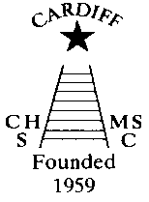
CHAMELEONS NEWS
The monthly newsletter of the Cardiff Chameleons
Affiliated to: MENCAP Special Olympics GB
Special Olympics Wales Welsh Sports Association
Website: www.cardiffchameleons.co.uk
Registered Charity Number 1103879
VOLUME 30 - ISSUE 12 – DECEMBER 2023

SWIM SESSIONS
HOWELLS SCHOOL
The sessions for December are on the 3rd and 10th
There is now only one session and that is from 6.00pm to 6.45pm.
PLEASE NOTE: Due to work being carried out within the school grounds or pool maintenance, sessions may be cancelled. We will endeavour to let you know as soon as we can if this happens.
CMC S&S CLUB - the sessions for December are on Thursday 7th and 14th.

We restart in January 2024 on Thursday 4th for CMCS&S and Sunday 7th for Howells School.

Bowls Sessions
The last bowls session will be on Friday 22nd December and restart in January on the 12th.

CHRISTMAS BUFFET AND DISCO
This is being held on Friday 8th December at St. Philip Evans Community Hall, (Llanedeyrn Drive CF23 9UL) from 7.30pm
Entry is by ticket only and the cost is the same as last year at £10.00 per person.
Tickets are still on sale!
These will be available from Pamela at swim sessions and from Barrie at the bowls sessions.
You only have until the 4th December to get your ticket.
As we need to let the caterers know the numbers attending.

PEMBROKESHIRE PUFFINS’ GALA

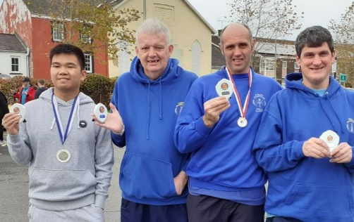
At team of 7 swimmers attended this gala and all had a successful day. Some are pictured here showing off what they won.

Photo courtesy of Pamela

Well, there goes another year!
It is that time of year again to thank all our coaches and volunteers and family who support in keeping our swim and bowls sessions going each week.

I’d like to thank those who have put on and help out on the various events we have throughout the year, such as Afternoon Tea and the Barbecue. Unfortunately, it is the same people each time; so, they know who they are.

Thank you to all our swimmers and bowlers who turn up each week, without them the Club would not exist.
Thanks too, for the support of the CMCS&S Club, Howells School and Cardiff Indoor Bowls Club, where we carry out our training sessions each week.

Finally, I wish you all a very Happy Christmas and New Year and look forward to your continued support next year, in what will be our 65th year as a Club.
Steve. (Chair.)

How to contact us
Coaches | Pamela – 029 2025 7314  07817 380355 pamela.bailey6@virginmedia.com
Coaches | Robin – 029 2021 8006
Coaches | Barrie – 029 2075 3038 / 07514 544619 barriejenkins50@live.com
Treasurer | Barrie Jenkins – 029 2075 3038 / 07514 544619 barriejenkins50@live.com  22 Heol Hir, Cardiff CF14 5AE
Newsletter  &  Chair | Steve – 029 2025 7314 / 07791 759360 stephen.bailey497@ntlworld.com  Items for the newsletter to be in 5 days prior to the end of the month. Please put it as a Word attachment if on e-mail
Other contacts | Ian – 029 2023 3065  Denise – 029 2075 2909
Club sessions
Swimming - Howells School – Sundays 6.00pm – 6.45pm.
Cardiff Medical Centre Sports & Social Club (UHW) – Thursdays 8.00pm – 8.45pm
Bowls – Cardiff Indoor Bowls Club – Fridays - 4.00pm – 6.00pm.

