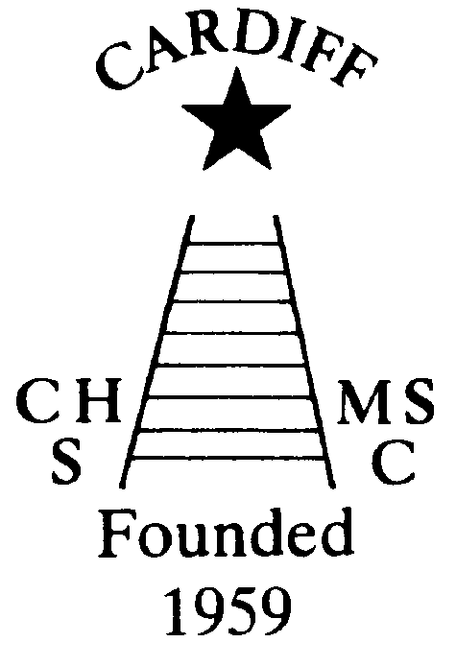
60 Years of
Achievement
Chameleons news 
The monthly newsletter of the Cardiff Chameleons
Volume 26: Issue 4: April 2019
Affiliated to:-Special Olympics GB, Special Olympics Wales, MENCAP,
Welsh Sports Association for People with Learning Disabilities.
Registered Charity No. 1103879
Website: www.cardiffchameleons.co.uk

1959

2019

60th Anniversary
Plans are now in hand for the meal which is taking place on Saturday 15th June at St. Peter’s Hall in Roath. Details of this event were put out in a letter in the March issue so if you are considering in joining us please can we have your reply by the 3rd May as requested.
Here are some other events taking place during the year.
A Club photograph will be taken on Sunday 7th April at 2.30pm at Howells School and will be taken in the area where we have our Afternoon tea and barbecues.I also want to take an individual photograph of all athletes.Please can you wear CLUB POLO SHIRTS (not the Special Olympics ones) the swimmers to wear their blue and bowlers to wear their white ones.
The Summer Afternoon tea will take place on July 7th from 2pm until 5pm and will be held at Howells school as usual and this year we think a 60’s theme would fit the bill. So mini-skirts and flowery shirts with butterfly collars to be worn and we’ll play 60’s music!
Our Club swimming gala is going to be a little bit special too, as we are going to invite swimmers to join us from two local clubs, Bridgend Sharks and Swansea Stingrays, and this will be on Tuesday August 6th with the Presentation evening on Tuesday 13th. However, as St. Philip Evans hall is booked that evening, we are going to be at the Cardiff Medical Centre Sports & Social Club, on the Heath hospital site, the same room as the swimmers & bowlers had their Christmas disco.
So please try not to book your holidays over these dates.
Pamela has booked a coffee morning for Thursday 17th October at St. Philip Evans Hall from 10am – 12noon.
Chameleons Anniversary 1959 – 2019
Celebrate by buying / selling our new Flashlight Pen.
Ideal for the winter nights!
Only £1.50 each [OR 3 for £4.00 – Bargain!]
Please contact Elaine for your supply of pens. Many Thanks Elaine Daw – Tel:02920 764770 elainemdaw@googlemail.com
At our last meeting, a suggestion was put forward about having hoodies made up in our Club colour of blue with yellow lettering. It will have the club logo embroidered on the front and then on the back 1959 - 2019 60 years of achievement.
We will bring one around to show and if you would like one, we will take your order. This is designed not to be part of the Club-wear when we go away but as all round leisurewear. The cost will be £20 each.
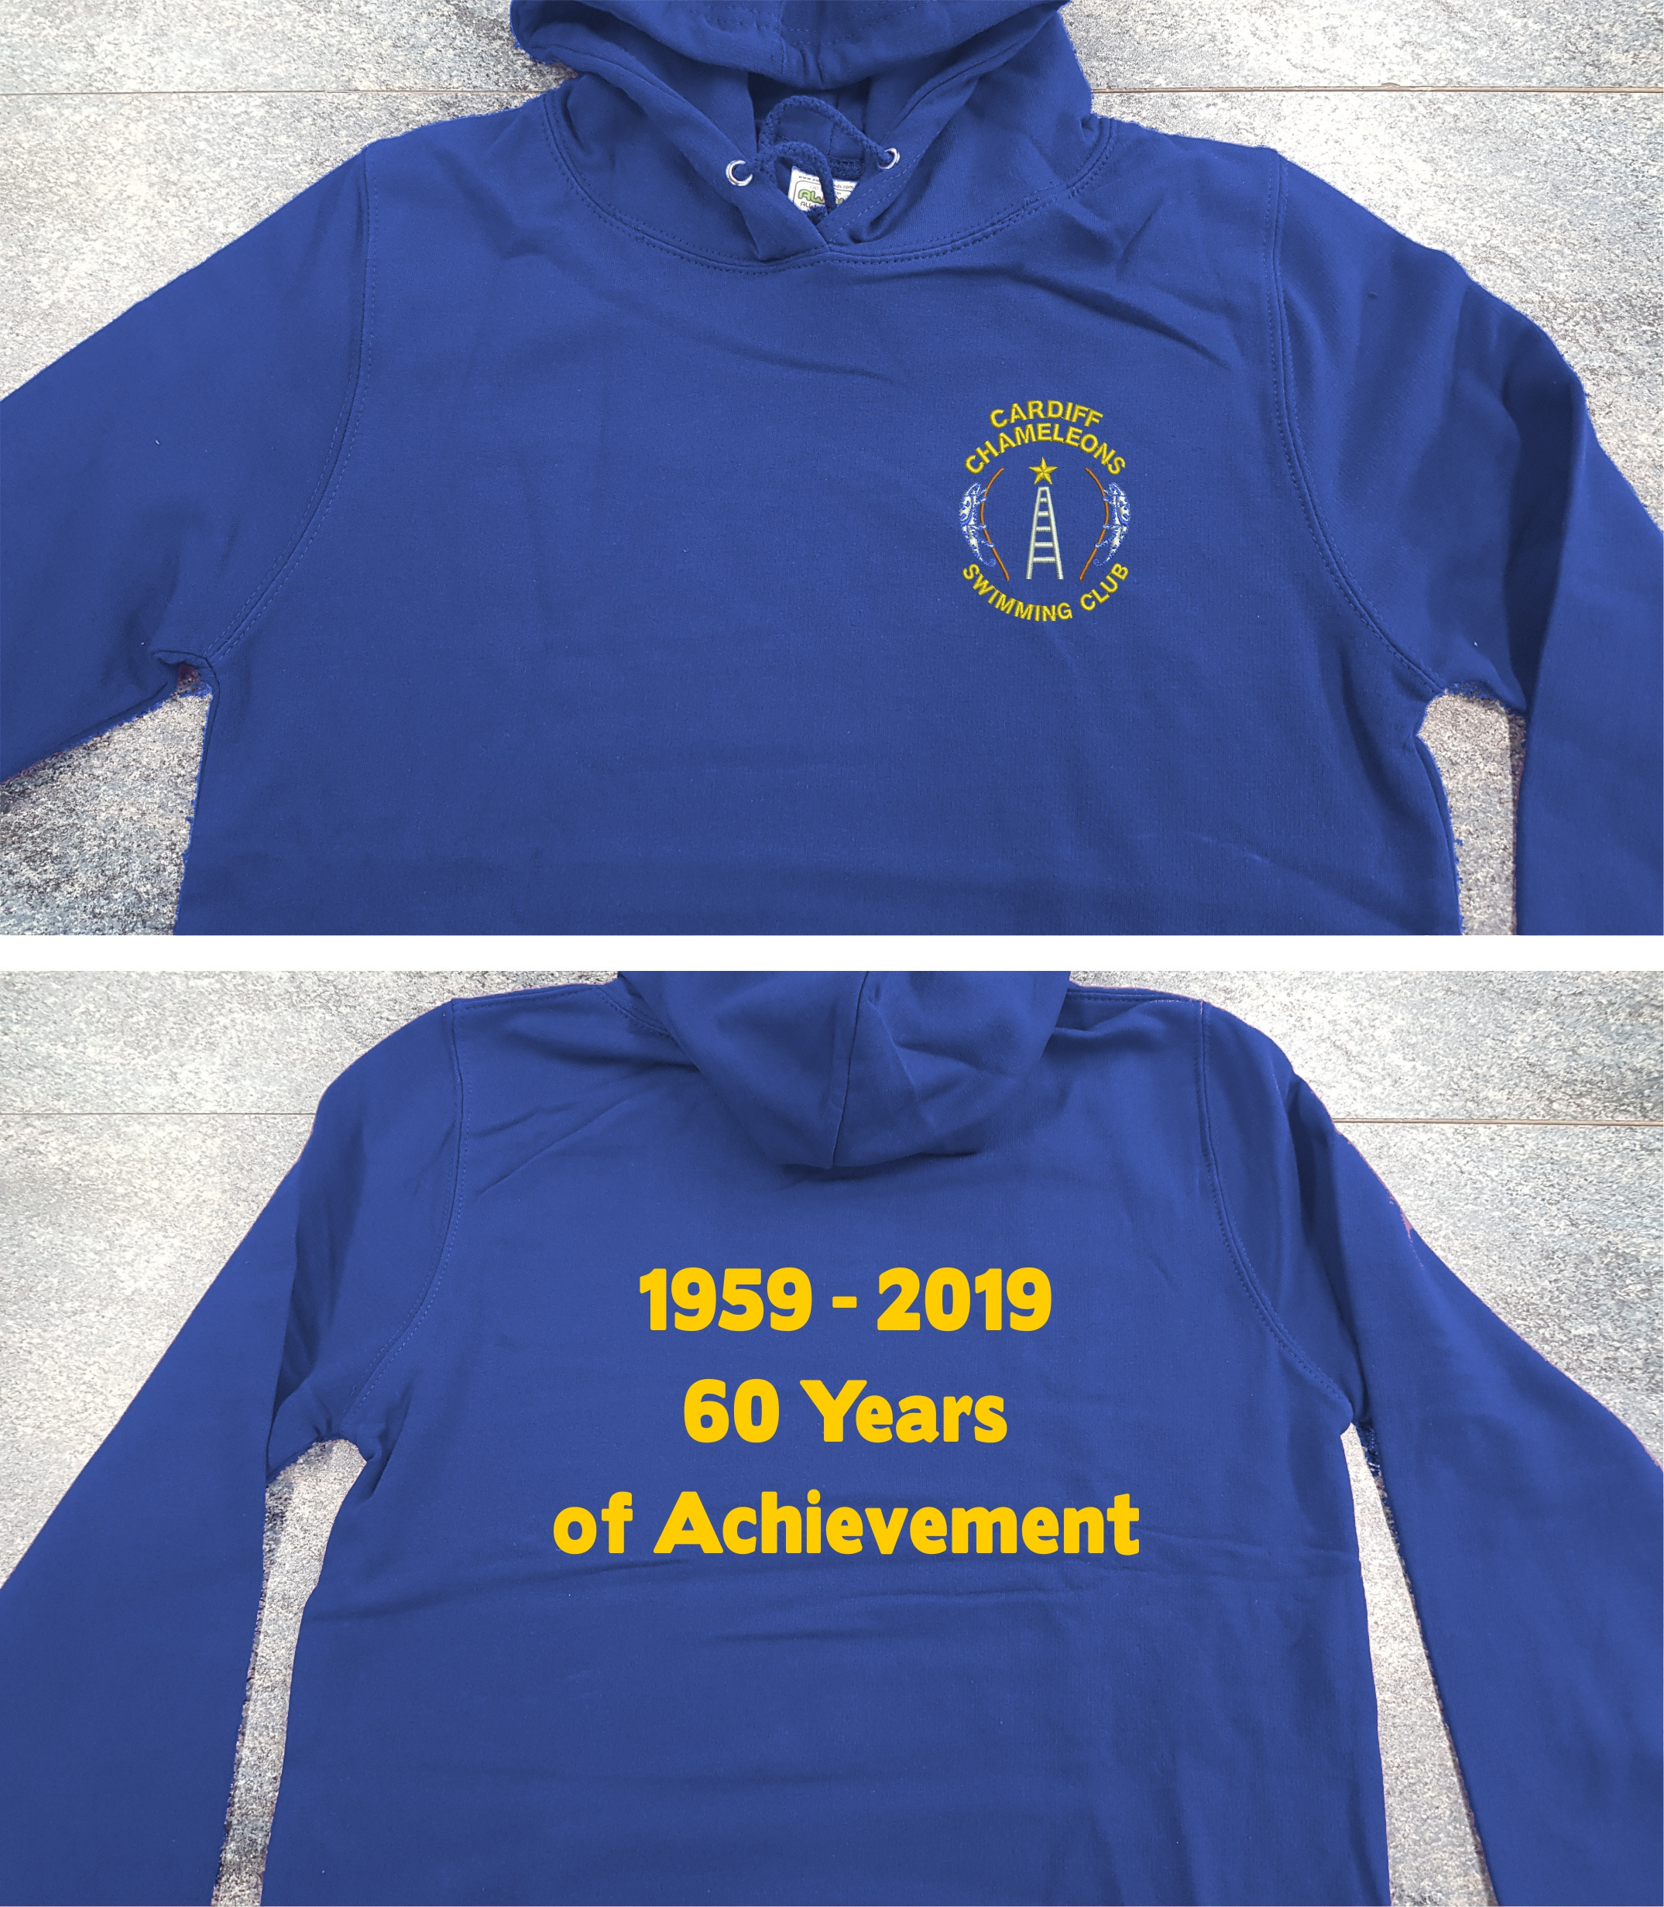
As we have not received the sample
Garment, they did send me a photo of
how the Hoodie will look.

There will no swimming sessions on the following dates:-
Monday 22nd and Tuesday 23rd April as this is the Easter bank holiday
Monday 6th and Tuesday 7th May as this the May Day bank holiday
Monday 27th and Tuesday 28th May as this is Spring bank holiday
“100” Club
The March winners are:- £20 Barrie Jenkins, £10 Ian Marshall and £5 Freda Bailey. Congratulations!
Keith Daw has had a short spell in hospital after having a fall whilst putting out the bins! He fractured his femur (thigh bone) and now has a few bits of metal in him. He is now back home and we wish him a speedy recovery.
The Special Olympics North West regional gala, (or as we know it as the Cheshire Penguins Gala). This is being held on Saturday 18th May in Liverpool so we will be travelling up on the Friday and return on the Sunday.
(Entry for this event is now closed)
“PODS”
The Penarth Operatic & Drama Society are doing a production of “Sweeney Todd” a musical thriller!
We are arranging to see this on Thursday 16th May, so if you are interested please contact Denise on 2075 2909 for details and tickets.
Sandra Jones is running an on-line shop on Facebook, if anyone has any items to sell in aid of Chameleons, please contact Sandra.
Well done to Richard Marshall, John Stafford and Martyn Nethercot who attended a gala in Southampton over the weekend of 23rd / 24th March. They each did well. There were no medals at all at this competition!

Bowls Group - The Schedule for 2019.
Sunday 14th April – Development and Skill Assessment session for Tri-Nations 2-5pm
Monday 3rd June – 7th June - Learning Disability Tri-Nations International Falkirk. Team of 12 from Wales by selection.
Wednesday 12th June - Great Western Bowls tournament 16 names required.
September 7/8 - Regional Bowls Competition Pembroke. More details to follow.
Any queries please speak to any of the coaching team.

The Coaching Team.

Margaret Krawiecha, Delyth Jenkins

Sandra Jones, Barrie Jenkins, Dave Medlam.

The bowls group went down to Torquay over the weekend of 22nd to 24th March. A group of 31 went to this regular event. More detail on how this went will be on the website,
SPECIAL OLYMPICS UK NATIONAL SUMMER GAMES - LIVERPOOL – 2021
The 11th National Summer Games will be held from Tuesday 3rd until Sunday 8th August.
Our Club now comes under the heading of Cardiff and the Vale but still under Special Olympics Wales. This does not however change the criteria for attending these games or any other games. You will still need to attend 26 weeks of training and to have attended a Regional competition.
Preparations are under way in getting a Welsh team together.
How to contact us
Pamela  (swim coach) | 2025 7314  07817 380355 | pamela.bailey6@virginmedia.com  Committee member
Robin  (swim coach) | 2021 8006
Barrie  (Bowls coach) | 2075 3038 | barriejenkins50@live.com  Committee Vice Chair
Elaine | 2076 4770 | elainemdaw@googlemail.com  Club Treasurer
Denise | 2075 2909 | Committee member
Ian | 2023 3065 | Committee member
Jane |  | Committee member
Heather |  | Committee member
Sandi |  | Minute Secretary
Steve  (newsletter) | 2025 7314  07791 759360 | stephen.bailey497@ntlworld.com  Committee chair  33 Ty Cerrig, Cardiff. CF23 7DP
Club Sessions
Swimming | Monday | Pentwyn LC 8pm – 8.45pm
Swimming | Tuesday | Eastern LC 8.30pm – 9.15pm
Bowls | Friday | Cardiff Indoor Bowls Club,  Sophia Gardens 4pm – 6pm
Any items for the newsletter need to be in 5 days prior to the end of the month. Please put them in a word document and as an attachment to the e-mail. Thank you.
Articles submitted to the newsletter are included as written and are not subject to changes or necessarily the view of the editor.

