Elaine Daw is now out of hospital and we wish her a speedy recovery at home.

Pentwyn & Eastern Leisure Centres
This is the latest…
Pentwyn LC: we cannot see us returning for a couple of years. The Mass Vaccination Centre is only on hold and may be used for the autumn booster jab up until February 2022 and the refurbishment of the pool etc. won’t begin until then.
Eastern LC: is gradually re-opening certain parts and when they think that classes / groups can return to the pool they will let us know.
Many thanks to Robin for making these inquiries.

Swim sessions at Howells School on Sunday evenings.
We have 2 sessions. The first session is from 6pm until 6.45pm and the second session is from 6.45pm until 7.30pm.
At the present time we can only have 6 swimmers per session.
To attend sessions, please contact Pamela.
Advance notice: There won’t be a swim session on Sunday 8th August.

AFTERNOON TEA
We are holding this fundraiser on Sunday 18th July. Admission is £3.00 and you pay on entry. As usual, we will provide the food and all you have to do is bring your drinks, money to buy raffle tickets and cakes and an appetite!! I may even throw in a quiz too!
You will need to book places so that we know how many to cater for.
You can do this, by e-mail, text, or phone either to me or Pamela, our contact details are in this newsletter.
There will not be a swim session that evening.

The Barbecue has been arranged for Sunday 29th August. This will start at about
3pm. Our chefs Sandi and Carson are pleased to do the cooking again for us this year! Again we will provide the food and you to bring your drinks and as there is no charge for this event, we will have our usual raffle to raise funds. There will be a swimming session in the afternoon but not in the evening.

“50+” Club
I have deferred the draw for June to be done with July’s draw. The winners will be notified then and shown in the August issue.

Annual General Meeting
This was cancelled due to Elaine being in hospital and will be held at a later date and when she is well enough to attend.

Swimmers Zoom Meetings
Pamela has decided that we no longer need to have these meetings as the people who joined in now come to our swim sessions at Howells school and we are now meeting face to face. It was really good at the time when we couldn’t meet up and it was nice to chat about what we had done in between the meetings.

FREE to a good home!
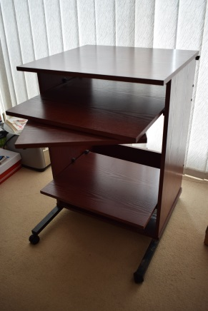
I have a computer workstation that is surplus to requirements. If anyone is interested please let me know.

How to contact us
Coaches:
Swimming
Pamela – 07817 380355
029 2025 7314 pamela.bailey6@virginmedia.com

Robin 029 2021 8006

Bowls
Barrie 029 2075 3038 / 07514 544619 barriejenkins50@live.com

Treasurer: Elaine 029 2076 4770
elainemdaw@googlemail.com

Newsletter: Steve 029 2025 7314 / 07791 759360 / stephen.bailey497@ntlworld.com 33 Ty Cerrig Cardiff CF23 7DP
Items for the newsletter to be received 5 days before the end of the month and as a word attachment if sent by e-mail
Denise  029 2075 2909 | Ian  029 2023 3065

