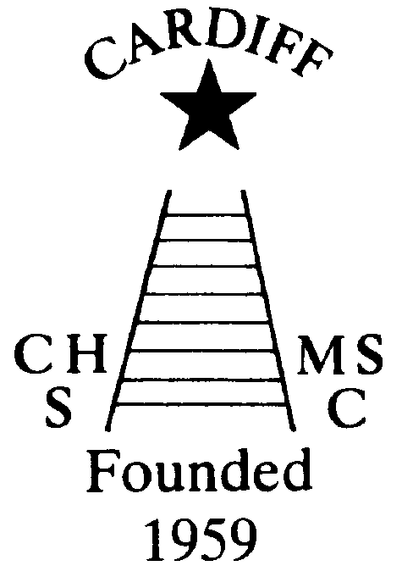
“100” Club
Chameleons’ news 
The monthly newsletter of the Cardiff Chameleons
Volume 25: Issue 12: December 2018
Affiliated to:-Special Olympics GB, Special Olympics Wales, MENCAP,
Welsh Sports Association for People with Learning Disabilities.
Registered Charity No. 1103879
Website: www.cardiffchameleons.co.uk

This restarts next month! If you wish to play again this year, or even join in, then please send me your £12.00 as soon as you can, my address is on the contacts page. You will have the same numbers as last year. Cheques made payable to Cardiff Chameleons. Thank you.

CHRISTMAS
Pamela is arranging a coach trip to the Christmas Market in Worcester. This will be on Saturday 1st December and is open to anyone and will cost £20.00 per person. Please give your name if you would like to go. It is an ideal way of doing some of your Christmas shopping.

Our Christmas Dinner and Dance will be held at
St. Philip Evans Hall on Friday 7th December. The dress code is smart casual, i.e. NO jeans, trainers, joggers etc. Please arrive from 7pm for a 7.30pm. start

A Christmas Disco for swimmers and bowlers has been arranged for Thursday 20th December at the Cardiff Medical Centre Sports & Social Club at the Heath Hospital. Starting about 7pm, there is no charge all we want you to do is to bring a plate of food for the buffet.
Please can you give your name if you are attending to Pamela.

The PODS pantomime this year is “Pinocchio”. We have got tickets for the performance on Thursday 6th December. If you wish to come with us to see this, then please contact Denise.

MEMBERSHIP RENEWAL
All members of the swimming and bowls should by now have renewed their membership. If not please do so, the fee is £15.00 for the year. Please make payment to our Club treasurer- Mrs Elaine Daw, 11 St. Edeyrn’s Road, Cyncoed, Cardiff CF23 6TB.
Cheques made payable to Cardiff Chameleons

HIJINX CHRISTMAS PRODUCTION
This year Hijinx are once again performing their popular Christmas production entitled HANSEL GEDEON and the GRIMMS’ WOOD at the Western Studio, Wales Millennium Centre on Thursday 6th Friday 7th and Saturday 8th December. Performances are at 7.00pm on each evening as well as 3pm on Saturday. Tickets are available from the WMC and are priced at £9 for adults and £6 for under 16s.
This is a sparkling new production with a large cast of disabled and non-disabled performers. It’s an ideal opportunity for the whole family to enjoy a Christmas treat.

Vision 21 CHRISTMAS FOOD AND CRAFT FAYRE
This will be held at Sbectrwm Community Centre, Fairwater on Friday 7th December from 10am – 2pm with 20p entry. This is always a popular event with many stalls. All proceeds go to Vision 21.
60 Years of Achievement
1959
2019
60th Anniversary
We are now only one month away from the start of our 60th celebratory year!
At present we only have the dinner in June on the go and Barrie is organising a Bowls competition in March and Pamela will be organising guest teams to compete at our Club gala in August. We had 2 entries to design a medal to use at these competitions.
It would be nice if we could do more speciality events other than just jazzing up our normal annual events. Do you have any ideas? Would you be prepared to run them?
Please let the committee know of any ideas you may have.

I propose to do a Club photograph sometime in March.

Chameleons Anniversary 1959 – 2019
The Clubs 60th Anniversary is nearly here !
Celebrate by buying / selling our new Flashlight Pen.
Ideal for the winter nights! Or stocking fillers ?
Only £1.50 each [OR 3 for £4.00 – Bargain!]
Please contact Elaine for your supply of pens.
Many Thanks Elaine Daw – Tel:02920 764770 elainemdaw@googlemail.com

Torquay Disabled Bowls Tournament – Friday 22nd March to Sunday 24th March, 2019.
Arrangements are in hand for our weekend in Torquay next year.
We shall leave Cardiff on Friday 22nd March in the morning [time and venue to be confirmed] and return
late afternoon on the Sunday 24th March.
If you wish to attend, please ask Elaine Daw [20764770] elainemdaw@googlemail.com for details.
Thank You. Elaine

One of our bowlers, Ian Kelleher, his dad is making a limited number of wooden reindeer to sell for Christmas. They cost £15 each and £5 will come to the Chameleons and is on a first come first served basis.
To order your reindeer call Lesley Kelleher (Ian’s mother) on (029) 2115 7065.

CHRISTMAS BREAK
Swimming – the last sessions will be on Monday 17th and Tuesday 18th December, recommencing on Monday 14th and Tuesday 15th January.

The bowls group, well you will be informed of your closing period by Barrie.



A very merry Christmas and a happy New Year to all the Club members, their families and to those who support the Club.
From the Committee.

How to contact us
Pamela  (swim coach) | 2025 7314  07817 380355 | pamela.bailey6@virginmedia.com  Committee member
Robin  (swim coach) | 2021 8006
Barrie  (Bowls coach) | 2075 3038 | barriejenkins50@live.com  Committee Vice Chair
Elaine | 2076 4770 | elainemdaw@googlemail.com  Club Treasurer
Denise | 2075 2909 | Committee member
Ian | 2023 3065 | Committee member
Jane |  | Committee member
Heather |  | Committee member
Sandi |  | Minute Secretary
Steve  (newsletter) | 2025 7314  07791 759360 | stephen.bailey497@ntlworld.com  Committee chair  33 Ty Cerrig, Cardiff. CF23 7DP
Club Sessions
Swimming | Monday | Pentwyn LC 8pm – 8.45pm
Swimming | Tuesday | Eastern LC 8.30pm – 9.15pm
Bowls | Friday | Cardiff Indoor Bowls Club,  Sophia Gardens 4pm – 6pm
Any items for the newsletter need to be in 5 days prior to the end of the month. Please put them in a word document and as an attachment to the e-mail. Thank you.
Articles submitted to the newsletter are included as written and are not subject to changes or necessarily the view of the editor.

