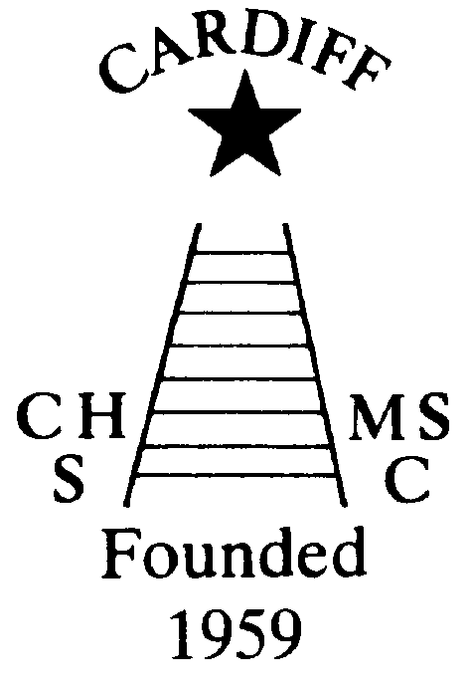
60 Years of
Achievement
Chameleons news 
The monthly newsletter of the Cardiff Chameleons
Volume 26: Issue 5: May 2019
Affiliated to:-Special Olympics GB, Special Olympics Wales, MENCAP,
Welsh Sports Association for People with Learning Disabilities.
Registered Charity No. 1103879
Website: www.cardiffchameleons.co.uk

1959

2019

60th Anniversary
Plans are now well in hand for the meal which is taking place on Saturday 15th June at St. Peter’s Hall in Roath. Details of this event were put out in a letter in the March issue so if you are considering in joining us, there are only a few days to go, so please can we have your reply by the 3rd May as requested.
A Club photograph was taken on Sunday 7th April at Howells School. At least it was a dry and bright day and a good number turned up but very disappointed that only some swimmers attended. I have been coming around to show you the best photograph to you all and you will be able to order a 7”x5” photograph mounted in a folder for £12.00. I will give 60% of the profit made back to the Club for funds!
Those of you who have ordered a copy will have them at the swim sessions the week after the bank holiday so that will be Monday 13th and Tuesday 14th and the bowlers will get theirs on Friday 10th May. If you haven’t paid for it I will need payment on those dates.
Here are some other events taking place during the year.
The Summer Afternoon tea will take place on July 7th from 2pm until 5pm and will be held at Howells school as usual and this year we think a 60’s theme would fit the bill. So mini-skirts and flowery shirts with butterfly collars to be worn and we’ll play 60’s music!
Our Club swimming gala is going to be a little bit special too, as we are going to invite swimmers to join us from two local clubs, Bridgend Sharks and Swansea Stingrays, and this will be on Tuesday August 6th with the Presentation evening on Tuesday 13th. However, as St. Philip Evans hall is booked that evening, we are going to be at the Cardiff Medical Centre Sports & Social Club, on the Heath hospital site, the same room as the swimmers & bowlers had their Christmas disco.
So please try not to book your holidays over these dates.
Pamela has booked a coffee morning for Thursday 17th October at St. Philip Evans Hall from 10am – 12noon.

Chameleons Anniversary 1959 – 2019
Celebrate by buying / selling our new Flashlight Pen.
Ideal for the winter nights!
Only £1.50 each [OR 3 for £4.00 – Bargain!]
Please contact Elaine for your supply of pens.
Many Thanks Elaine Daw – Tel:02920 764770 elainemdaw@googlemail.com

60th Anniversary Hoodie
We now have a sample of the Hoodie which was shown and modelled by some of us at the photoshoot and we have already had some orders. The Hoodie is for sale at £20.00 each and is intended to wear for leisure and not just for the swimmers or bowlers; anyone who is involved with the Club can buy them!! An order form is on page 7 and a photo of it on the back page.

OTHER NEWS
There will no swimming sessions on the following dates:-
Monday 6th May as this the May Day bank holiday. However, Pamela is doing the session on Tuesday 7th.
Monday 27th and Tuesday 28th May as this is the Spring bank holiday.
“100” Club
The April winners are:- £20 Jane Ratcliff, £10 Elaine Daw and £5 Kristina Rees. Congratulations!
GOOD LUCK!
To the swim team attending the Special Olympics North West Regional Gala in Liverpool on the 18th May.

“PODS”
The Penarth Operatic & Drama Society are doing a production of “Sweeney Todd” a musical thriller!
We are arranging to see this on Thursday 16th May, so if you are interested please contact Denise on 2075 2909 for details and tickets.

British Learning Disability Swimming Championship
This event is being held in Liverpool on Saturday 7th September. We will go up on Friday 6th and return on Sunday 8th. Please can Pamela have your name if you would like to attend by Friday 5th July as we will need to book accommodation etc. Cost will be available once we know how many are attending.

Sandra Jones is running an on-line shop on Facebook, if anyone has any items to sell or in fact buy from her in aid of Chameleons, please contact Sandra.
You may have noticed that we have not mentioned anything about the manning of the Plant Crèche at the RHS Flower Show which was held in Cooper’s Field last month. Well the simple answer is “we were not required”. Yes, it is disappointing as it is a good fund-raiser for us.
Bowls Group - The Schedule for 2019.
Monday 3rd June – 7th June - Learning Disability Tri-Nations International Falkirk. Team of 12 from Wales by selection.
Wednesday 12th June - Great Western Bowls tournament 16 names required.
September 7/8 - Regional Bowls Competition Pembroke. More details to follow.
Any queries please speak to any of the coaching team. Margaret Krawiecha, Delyth Jenkins

Sandra Jones, Barrie Jenkins, Dave Medlam.

Welsh Learning Disability Indoor Bowls Singles Championship.
Sunday 31st March saw the crowning of three Welsh Learning Disabilities indoor Bowls Champions.
L1 Classification - Cameron White ( Heatherton and Special Olympics West Wales)
L2 Classification - Millie Campbell (Cardiff Chameleons and SO Cardiff and Vale)
L3 Classification - John Lister (Radnorshire IBC )
Well done to all 36 competitors who took part in the first Welsh Learning Disability Indoor Bowls Singles Championship. Some tremendous bowling was witnessed by almost 90 competitors, supporters and officials at Cardiff Indoor Bowls Club on Sunday 31st March 2019.
Bowlers from Pembroke, Radnorshire, Islwyn, Rhondda and 19 bowlers from Cardiff Chameleons, took part in Round Robin competitions in three separate classifications. The winners and runner-up in each Classification going on to the Semi-Finals and Finals to determine the Welsh Champion
In each Classifications. It was good to see the ladies well represented in all three classifications. Four of them made it through to the semi-finals and three managing to reach the finals.
The L3 Classification final was between John Lister of Radnor and Garon Owen of Cardiff Chameleons. John Lister saving his best bowls for the final and becoming the Welsh L3 Classification Singles Champion.
The L2 Classification was a hotly contested all female final which was eventually won by Millie Campbell, from RCT and a Cardiff Chameleons Bowler. The runner-up in L2 was Lorna Clarke from Radnor, competing in her first bowls competition.
In the L1 Classification Cardiff Chameleons bowler Naomi Baelz, competed against Cameron White from Whitland, a member of the Heatherton Club. This was a superb demonstration of the drawing game by both players Cameron being a worthy winner.
My Sincere thanks to the Coaches and Volunteers from all the clubs, the Markers and Supporters from Cardiff Chameleons and the management from Cardiff IBC for their support.

How to contact us
Pamela  (swim coach) | 2025 7314 | pamela.bailey6@virginmedia.com  Committee member
Robin  (swim coach) | 2021 8006
Barrie  (Bowls coach) | 2075 3038 | barriejenkins50@live.com  Committee Vice Chair
Elaine | 2076 4770 | elainemdaw@googlemail.com  Club Treasurer
Denise | 2075 2909 | Committee member
Ian | 2023 3065 | Committee member
Jane |  | Committee member
Heather |  | Committee member
Sandi / Pamela |  | Minute Secretary
Steve  (newsletter) | 2025 7314 | stephen.bailey497@ntlworld.com  Committee chair
Club Sessions
Swimming | Monday | Pentwyn LC 8pm – 8.45pm
Swimming | Tuesday | Eastern LC 8.30pm – 9.15pm
Bowls | Friday | Cardiff Indoor Bowls Club,  Sophia Gardens 4pm – 6pm
Any items for the newsletter need to be in 5 days prior to the end of the month. Please put them in a word document and as an attachment to the e-mail. Thank you.

CARDIFF CHAMELEONS 60th ANNIVERSARY HOODIE
ORDER FORM

Please order me the following hoodie(s)

Size | Quantity
S
M
L
XL
2XL
3XL

Total number required ________ at £20.00 each

Total cost £___.____ cash / cheque

Please make cheques payable to “Cardiff Chameleons”

Name:

Contact number:

Thank you for your custom and support.

Registered Charity No. 1103879

