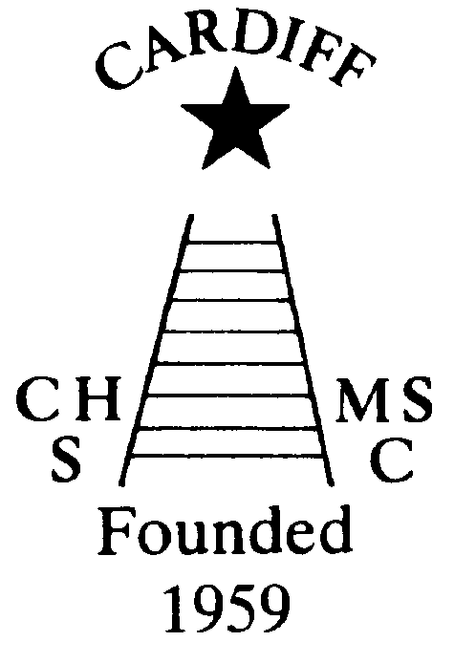
“100” Club
Chameleons’ news 
The monthly newsletter of the Cardiff Chameleons
Volume 25: Issue 8: August 2018
Affiliated to:-Special Olympics GB, Special Olympics Wales, MENCAP,
Welsh Sports Association for People with Learning Disabilities.
Registered Charity No. 1103879
Website: www.cardiffchameleons.co.uk

July winners were:-
£20.00 No.36 Christopher Bourne
£10.00 No.50 Marie Macey
£5.00 No.4 Pamela Bailey
The lucky winners have been notified. The next draw will be on the 15th August.
The last draw for the year will be held next month. If you wish to continue or would like to join in, further details will be in the September issue.

AFTERNOON TEA
A wonderful afternoon, on blazing, hot Sunday, in July (yes! Really it was!) A little lower on numbers about 30 of us in all enjoyed sandwiches cakes, squash and tea / coffee. It was also nice to see Louise Daw come and join us too! We raised a total of £168.50.
There are some photographs on the website.

CLUB GALA
This is on Tuesday 7th August at Eastern LC. Starting at 7.15pm, so please arrive by 6.45pm! We should be finished by 9pm. Not only the swimmers have to attend but it would be nice to see some supporters too!
Please bring back the trophies you won last year to the gala.
The Presentations will be the following Tuesday (14th) at St. Philip Evans Church Hall starting at 7.30pm. Please bring a plate of food for the buffet, the bar will be open, and we’ll have the usual raffle.

PLEASE NOTE: The last swim session before a summer break will be on Monday 6th August. We will return on Monday 3rd and Tuesday 4th September.

ANNUAL GENERAL MEETING
This was held on Wednesday 25th July. Not a good turnout! The following items have come from this meeting that changes to the constitution were made. We are now to be called Cardiff Chameleons. We have dropped the “Swimming club” so as to incorporate the bowls team. Once this has been completed you can, if so desired, request a copy.
The Committee were also re-elected and congratulations to Barrie Jenkins who is now our vice-chair and we welcome Heather Knight and Jane Ratcliff as new committee members.

PRIVACY
As you may know by now a directive came into force about what information on you can be held by a company or charity and if you still want that information to be held.
As we have information on each member of the Club, whether you have a learning disability, guardian / carer or a supporter i.e. your name, address, e-mail, telephone number, photo / video consent and some of you, your medical details, which you have consented to give. We do not share any of this information to a third party, unless it is for completion of competition forms, and would naturally ask you first if it ever arose.
Therefore, we are asking you now if you are now willing for us to keep this information on computer or paper copy.
If you do not want us to keep information about you, please let me or any committee member know by the end of September. If we do not hear from you by then we shall take it that you are happy for us to keep your information.

CLUB BARBECUE
We are holding a barbecue at Howells School on Sunday 26th August. We hope to have a swim session from about 2pm to 3pm (subject to permission) and the afternoon will finish at about 5pm.
It is important that you let us know if you are going to attend as we will need to know how many to cater for.
Please bring a bottle (alcoholic or not) for a communal bar to share with everyone.
We will also have our usual raffle!

60th ANNIVERSARY
We will be celebrating 60 years as a Club next year and so we are looking for some ideas on how to celebrate it. A dinner is going to be held on June 15th at St. Peter’s Hall. We have thought of a Club photograph, a special gala and bowls competition and getting in some memorabilia such as pens. A sub-committee may need to be formed but if you have any ideas please contact me or another member of the committee.

BOWLS
Good Luck to those attending the 40thAnniversary Games of Special Olympics being in Great Britain. Special Olympics have been going for 50years since its conception in America by Eunice Kennedy- Shriver. Joyce Robinson signed up our Club to be the first in Britain to sign up to Special Olympics. Our Bowls group are representing us.
Bowls Team manager, Barrie, writes:-

Special Olympic Anniversary Games Stirling August 9th – 13th

A team of eight bowlers from Wales six of whom are members of Cardiff Chameleons Bowls section, will be attending the Anniversary Games in Stirling Scotland. The team will be flying to Glasgow from Cardiff Wales Airport on the 9th of August. They will arrive at Stirling University with time to settle in to their accommodation, before changing and attending the Opening Ceremony at Forthbank Stadium.
The Competition will start on Friday 10th August and conclude on Sunday 12th August each team member having competed in a Pairs and a Singles competition against bowlers from all over Scotland, as well as teams from Northern and Yorkshire and Humberside Regions.
We wish them good luck, a safe journey and an enjoyable stay at Stirling University.
Go WALES!!
But before they go up to Scotland they have a competition in Plymouth to attend first over the weekend of the 4th & 5th August, so GOOD LUCK there too!

COMING UP IN THE NEXT COUPLE OF MONTHS

Membership renewal – October

“100 Club” renewal - October

CARDIFF MENCAP CARAVAN
Fancy a week relaxing in west Wales? Then why not book the caravan which is situated in Penally just outside Tenby. Details of availability cost and bookings can be made through Denise Pearson on (029) 2075 2909.

How to contact us
Pamela  (swim coach) | 2025 7314 | pamela.bailey6@virginmedia.com  Committee member
Robin  (swim coach) | 2021 8006
Barrie  (Bowls coach) | 2075 3038 | barriejenkins50@live.com  Vice Chair
Elaine | 2076 4770 | elainemdaw@googlemail.com  Club Treasurer
Denise | 2075 2909 | Committee member
Ian | 2023 3065 | Committee member
Jane |  | Committee member
Heather |  | Committee member
Sandi |  | Minute Secretary
Steve  (newsletter) | 2025 7314 | stephen.bailey497@ntlworld.com  Committee chair
Club Sessions
Swimming | Monday | Pentwyn LC 8pm – 8.45pm
Swimming | Tuesday | Eastern LC 8.30pm – 9.15pm
Bowls | Friday | Cardiff Indoor Bowls Club,  Sophia Gardens 4pm – 6pm
Any items for the newsletter need to be in 5 days prior to the end of the month. Please put them in a word document and as an attachment to the e-mail. Thank you.
Articles submitted to the newsletter are included as written and are not subject to changes or necessarily the view of the editor.

