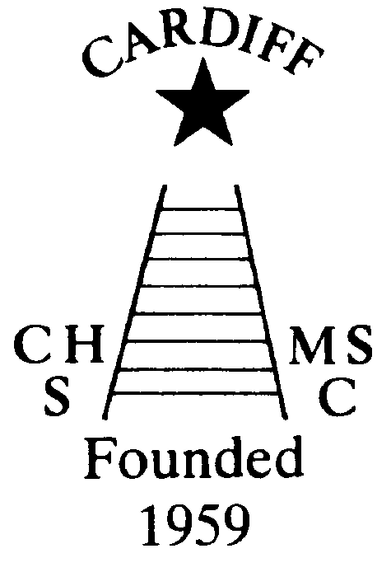
“100” Club
Chameleons’ news 
The monthly newsletter of the Cardiff Chameleons
Volume 25: Issue 7: July 2018
Affiliated to:-Special Olympics GB, Special Olympics Wales, MENCAP,
Welsh Sports Association for People with Learning Disabilities.
Registered Charity No. 1103879
Website: www.cardiffchameleons.co.uk

June winners were:-
£20.00 No. 3 Rose Marshall
£10.00 No.33 James Savory
£5.00 No.11 Gareth Clark
The lucky winners have been notified. The next draw will be on the 15th July.

BELATED CONGRATULATIONS to Denise who celebrated her 80th birthday last month.

CONGRATULATIONS to Jeff Savory on receiving the OBE in the Queen’s birthday honours.

Fantastic News!
As many of you are aware, the Chameleons were top in the Cardiff area for the Cash in the Communities recent Echo competition. The promotion was held between the South Wales Echo, the South Wales Evening Post and Western Power Distribution.
The club has been awarded £3,760.16!!!

Thank you to all who collected the tokens. We were able to send them in in their thousands!!!
However, the biggest thanks go to Margaret [Krawiecka] for entering the Chameleons in the first place and for organising the publicity.
Thank you All!!! Elaine

SUMMERTIME TEA
We are holding an “Afternoon Tea” at Howells School on Sunday 8th July. It will consist of sandwiches, cake and tea / coffee / bring your own wine. We will have our usual raffle too! Tickets are £3.50 and now on sale!
ALL WELCOME!

British Learning Disability Swimming Championships (BLDSC)
These are being held this year in Swansea on Saturday 1st and Sunday 2nd September. If anyone is interested in attending please give your name to Pamela. We may only need to attend the first day, it depends on the programme.
FINAL CALL ON THIS.

ANNUAL GENERAL MEETING
Unfortunately this had to be cancelled at late notice. The AGM is now due to be held on Wednesday 25th July at Howell’s school. It is important that you let me know if you are going to attend. My contact details are on the list

60th ANNIVERSARY
We will be celebrating 60 years as a Club next year and so we are looking for some ideas on how to celebrate it. A dinner is going to be held on June 15th at St. Peter’s Hall. We have thought of a Club photograph, a special gala and getting in some memorabilia such as pens. A sub-committee may need to be formed but if you have any ideas please contact me or another member of the committee.

CLUB GALA
This is to be held on Tuesday 7th August at Eastern Leisure Centre. Normally we would be asking you to start returning the trophies you won last year however, as Pamela and I are unable to have them, (as we are in the process of moving house), so, unless anyone else can take them, please can you bring them back on the night of the gala or at the presentation ceremony which is to be held a week later on the 14th August at St. Philip Evans church hall as last year.
However, we would like back the Endeavour Award, Best Achiever and Sports Personality back as soon as possible.

PLEASE NOTE: The last swim session before a summer break will be on Monday 6th August.

CARDIFF MENCAP CARAVAN
Fancy a week relaxing in west Wales? Then why not book the caravan which is situated in Penally just outside Tenby. Details of availability cost and bookings can be made through Denise Pearson on (029) 2075 2909.

BOWLS
Cardiff Chameleons sent four Rinks of Bowlers to the 2018 Great Western Bowls competition, which took place at Cotswold Indoor Bowls Club on Wednesday 13thJune.
Cardiff Blues team took this year’s title beating Cotswold Outsiders in the final playoff by 12 shots to nil. The Team of Robert Parker, Millie Campbell, Angus Pirrie and Naomi Baelz went undefeated throughout the competition and showed a very high class of bowls.
Cardiff Extra’s just got the better of Cardiff Chameleons in the 3rd and 4th place playoff, while Cardiff Reds finished in eighth spot being narrowly beaten in their games and showing great potential, two of the Reds team were experiencing their first away trip with the squad.
My thanks to John and Jenny for their assistance with transport. It wouldn’t have been possible without you.
Well done all. A long day but a rewarding one.

Diary
July 6th - No Bowls!! There is a One Day Cricket International at Sophia Gardens so the Club will be closed all day.

July 7th - 13th Test Series for the Atlantic Rim Outdoor bowls. There will be a Bowls Group training session on this date but there may be an issue with Parking.

*** July 20th - Provisional date for club competition presentation event - July 20th *** which is a Friday at the normal time of 4pm - An Hours Target Bowls followed by a light buffet (Please all bring a plate of food, sandwiches, finger food etc; cakes,) followed by the trophy presentations for the Club Singles and Doubles competitions.

The dates for competitions for 2018 are as follows:-
4-5th August.
Special Olympic, South West Regional event at Plymouth Life Centre. This is a Rinks competition (team of 4 players) Departing Saturday 4th August, overnight stay and Bowling from 9am – 4pm Sunday Return Sunday evening. Again please let us have names as soon as possible so that we can arrange accommodation and transport. The cost be approximately £56 per person, which covers accommodation, entry fee and transport

9th-13th August.
SO Anniversary Games Stirling Scotland. Team entries are closed for this competition. The second payment of £150 is due 25th May 2018 and the third and final payment is due on 29th June 2018. The final payment amount is not determined yet as the Transport cost to/from airports has not been finalised. I will inform all team members as soon as I have the details.
Please let the Coaching team know whether you’re available especially for the Club Singles competition, Great Western 13th June and the Plymouth Regional 4-5th August, so that we can plan teams, transport and accommodation. Costing and timings nearer the time.

How to contact us
Pamela  (swim coach) | 2025 7314 | pamela.bailey6@virginmedia.com  Committee member
Robin  (swim coach) | 2021 8006
Barrie  (Bowls coach) | 2075 3038 | barriejenkins50@live.com
Elaine  (Treasurer) | 2076 4770 | elainemdaw@googlemail.com  Committee member (Treasurer)
Denise | 2075 2909 | Committee member
Ian | 2023 3065 | Committee member
Heather |  | Committee member
Steve  (newsletter) | 2025 7314 | stephen.bailey497@ntlworld.com  Committee chair
Club Sessions
Swimming | Monday | Pentwyn LC 8pm – 8.45pm
Swimming | Tuesday | Eastern LC 8.30pm – 9.15pm
Bowls | Friday | Cardiff Indoor Bowls Club,  Sophia Gardens 4pm – 6pm
Any items for the newsletter need to be in 5 days prior to the end of the month. Please put them in a word document and as an attachment to the e-mail. Thank you.
Articles submitted to the newsletter are included as written and are not subject to changes or necessarily the view of the editor.

